Data entry instructions for the City’s bid database

General instructions on creating a bid 2

Federal stimulus money 12

How to modify a bid 16

When prime contractors want to solicit potential LBE subcontractors 20

Searching for an expired bid 22

Note on cancelling a bid 25

Error messages 26

General instructions on creating a bid

Go here: http://mission.sfgov.org/OCABidMaintenance/

And you’ll see this:

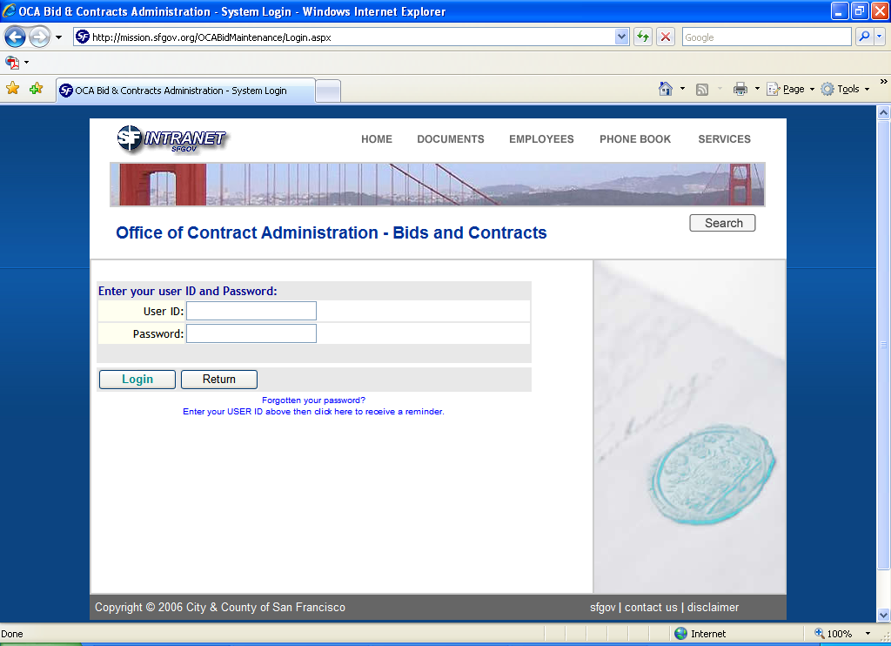

Enter your User ID and … oh, you know what to do. It’s not case-sensitive. The first time you log in, you have the default password the e-mail system told you about. Please change it immediately.

After you enter your password, you can click Login. Or, you can hit the Enter key once or twice, which saves time fumbling for the mouse.

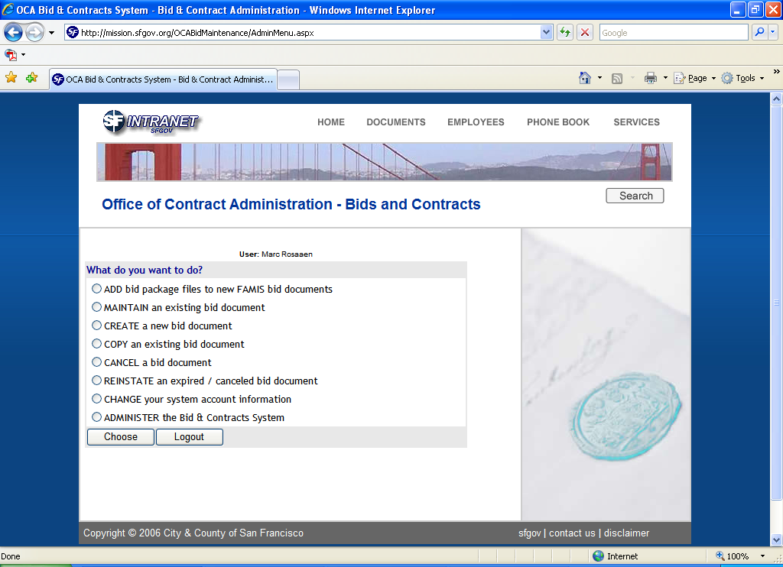

Once you have these menu picks in your heads, you can sing a million different tunes by mixing them up, like this …

Oops, no.

Select “CREATE a new bid document” if you want to add something new, or “MAINTAIN an existing bid document” if you’re revising a bid that’s already on the net. Or, do whatever you want to. Don’t listen to me.

Click Choose. Don’t hit Enter, because Choose isn’t highlighted. Hitting Enter will take you to the Search function.

Here’s the top half of the “Create a new bid document” screen:

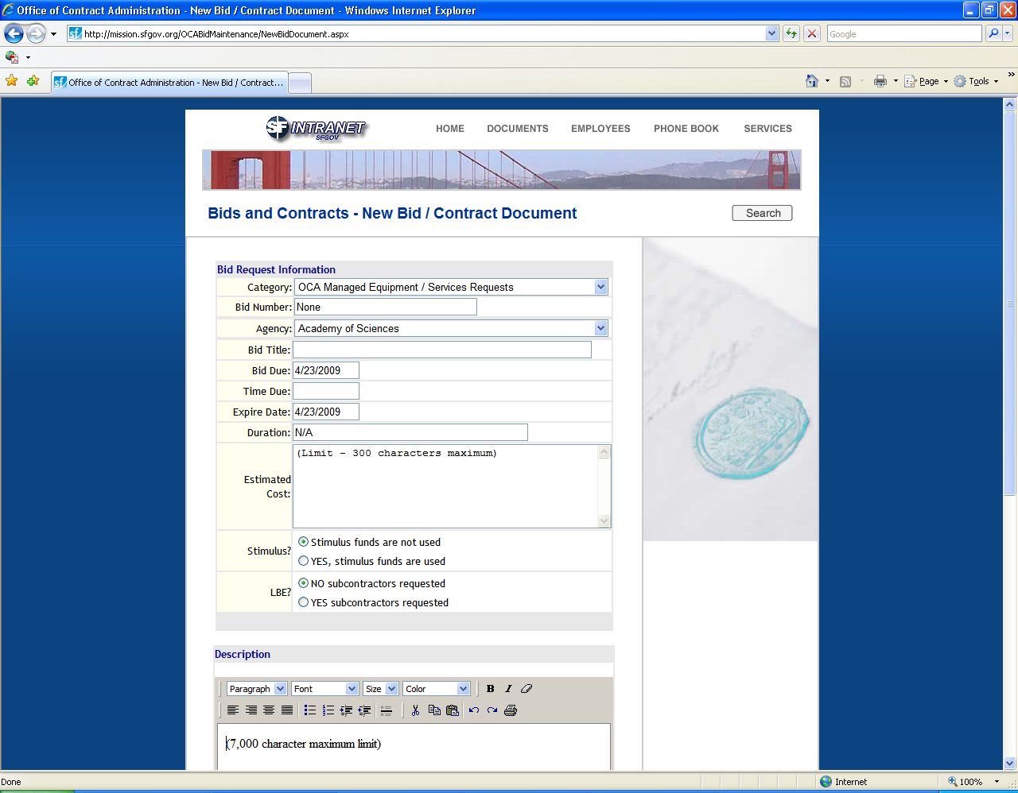

There are several check-off boxes or radio buttons on this data entry screen, and when they’re checked more fields appear. They are:

- LBE subcontractors requested
- Pre-bid conference
- Contact’s information
- File attachments

The screen shots of the two halves of the screen show the screen with no boxes checked YES, and thus with the fewest number of fields in view. As the check-off boxes are discussed, screen shots follow showing the newly visible fields.

Category: You can select any category, except Bids managed by OCA.

Bid number: Having a number is optional, but the field cannot be blank. If you’re not assigning a bid number, leave “None.”

Agency: The system knows where you work. Scary, isn’t it?

Bid title: Required.

Bid due: Required.

Time due: Optional.

Expire date: Required. At 11:59 p.m. on this date, the bid will disappear from the web. Where does it go? The same place the fire goes when it goes out, or maybe your lap goes when you stand up. Not really. It disappears from the web, but stays in the database so you can revive it if you want to.

Duration: Optional. Most often used for the estimate of how long the project will take.

Estimated cost: Optional.

Stimulus: This is new as of April 2009. If some or all of your bid or RFP is being paid for with federal stimulus money, click YES. The federal law providing the money is the American Recovery and Reinvestment Act, or ARRA. See page 10 for more information.

LBE: If the bid or proposal has LBE subcontracting goals, click YES. If not, check NO. Checking YES causes the red checkmark to appear on the bid listings, and causes a new field to appear in data entry:

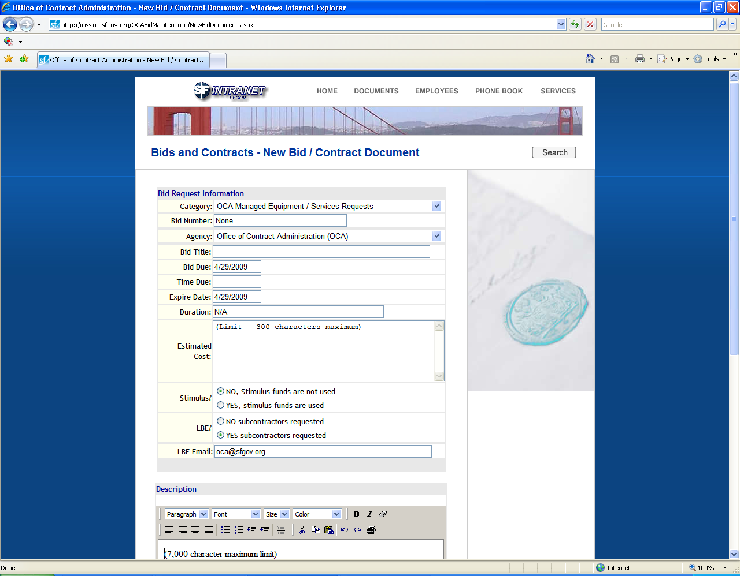

LBE e-mail: See page 17 for information on how to use this field. It’s a required field when you click YES.

Here’s the bottom half of the screen:

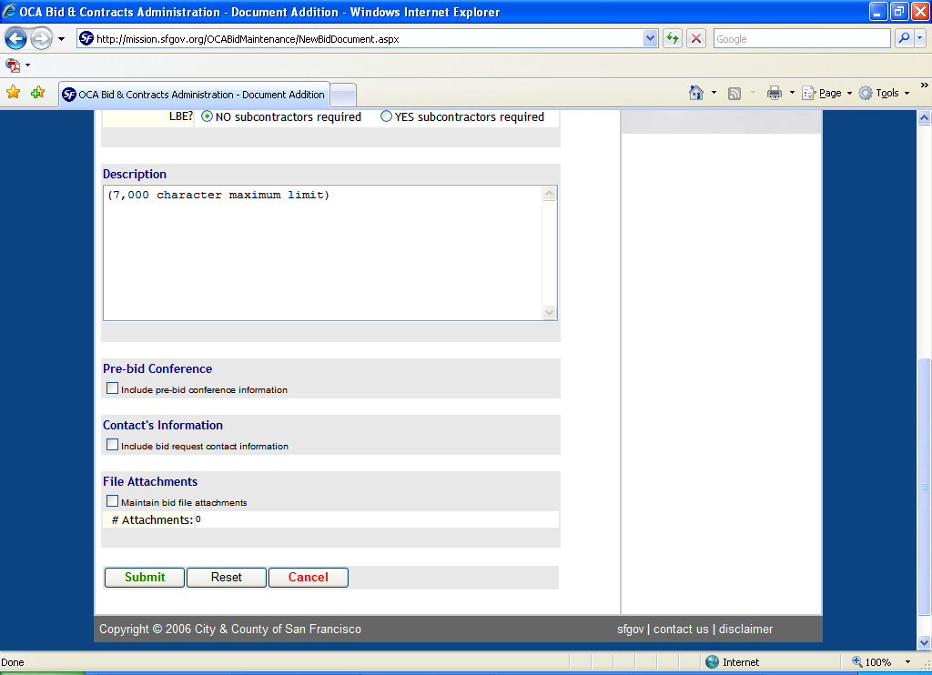

Description: Let your creative juices flow. This is where you put in everything in the world anyone would ever want to know about the bid.

Pre-bid conference: If you’re going to have a pre-bid conference, click the box. These fields appear:

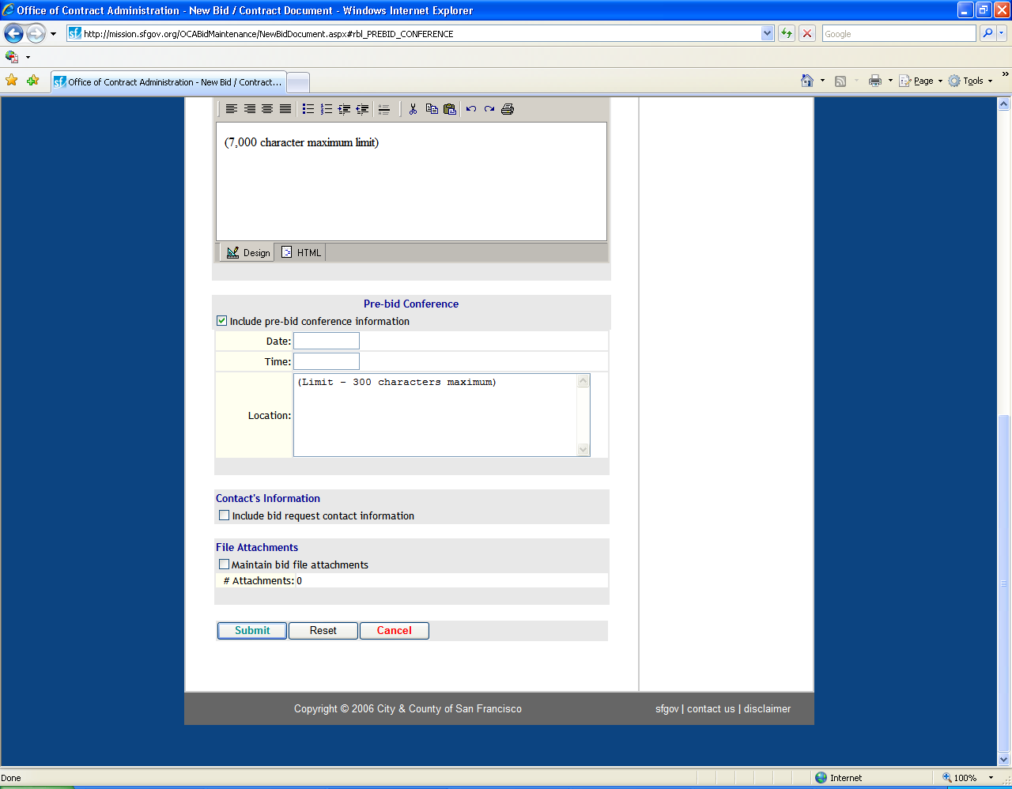

Date: Required.

Time: Required.

Location: Required.

Contact’s information: Optional, but almost all bids have some contact information. Clicking the box makes these fields appear:

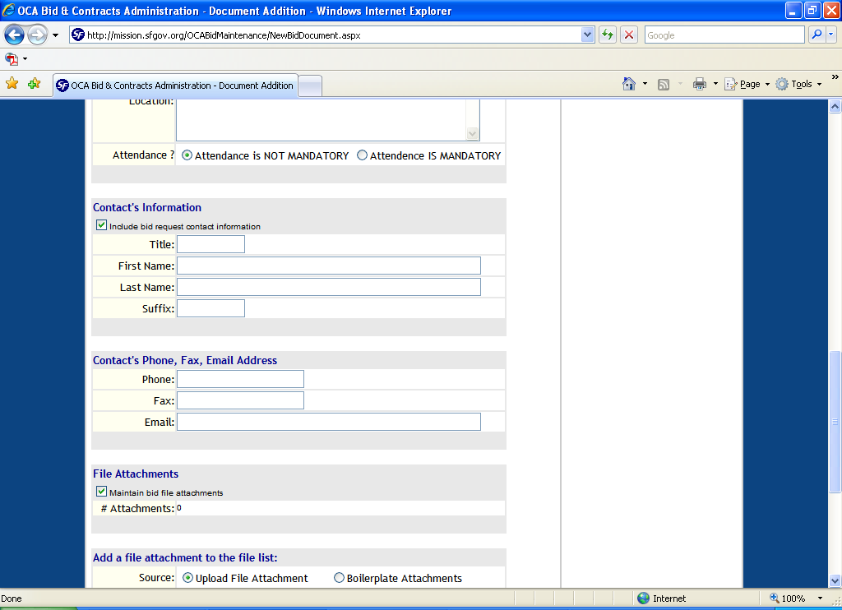

Title: Optional.

First Name: Optional.

Last Name: Optional.

Suffix: Optional.

Contact’s Phone, Fax E-mail Address

Phone: Optional.

Fax: Optional.

E-mail: Optional.

Although each of these seven fields is optional, you have to include at least one of the final three.

File attachments: Most bids have files attached. To attach something, click this box. Then this happens:

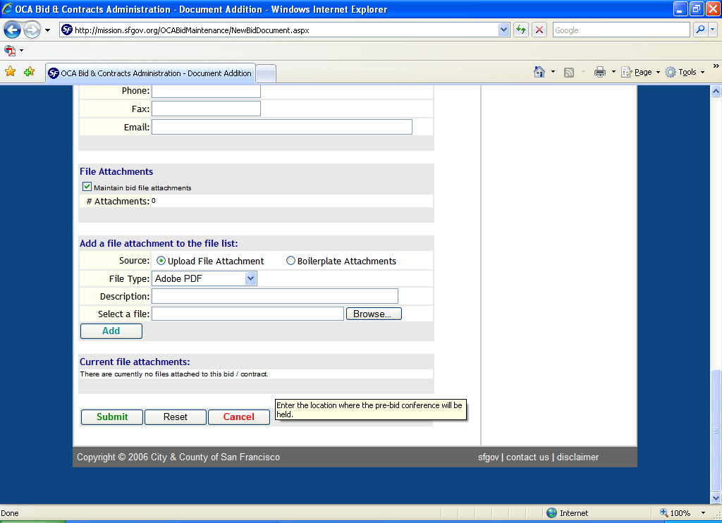

File Type: Required. You must select a file type from the drop-down list.

Description: Optional, but it’s extremely important. What you type here will look like the filename of the file you attach. The system changes the attachment’s original filename to a system identifier like “FA252,” which doesn’t tell the reader much, so you need to do your best here to give the reader an idea of what the attachment is.

Select a file: Put your curser here and click Browse. The system will take you to your PC or LAN, and you can go shopping. After you select the file, click Add. If the file you want to attach is too big, you’ll get an error message. See the last section of these instructions for more information.

After you click Add, the screen changes to this:

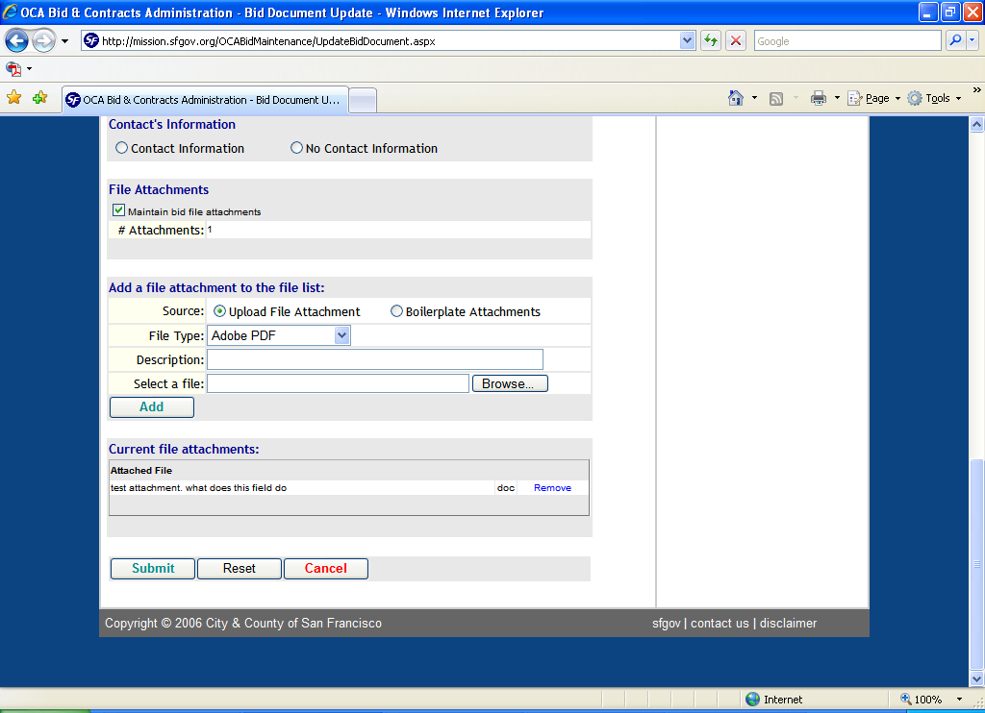

You’ll see (in tiny type) what you put in the Description field, what file type it is, and Remove in blue. Click Remove if you want to detach the file.

When you’re done, click Submit. The system will check that required fields are filled out correctly. If anything is missing, you’ll get polite reminders, in red, at the top of the page.

If you want to Remove a current attachment and Add a new one, do that as two separate operations. If you try to do both and then hit Submit, the system can’t cope and will do only one of the two things you asked it to do.

When viewers on the net download an attached file, the filename won’t be what you typed in the Description field. The system assigns a filename that won’t mean anything to anyone.

Federal stimulus money

In April 2009, the bid database was modified to accommodate bids and RFPs paid for in whole or in part with federal stimulus money from the American Recovery and Reinvestment Act (ARRA). If the bid you’re creating is one of those, then there’s a simple thing you need to do.

Below the Estimated Cost area is the Stimulus area. The system defaults to “NO, stimulus funds are not used.” But if you’re spending stimulus money, click “YES, stimulus funds are used.” The screen will blink, but no new fields will appear, unlike what happens when you click the YES button for the LBE item. The effects of checking this box appear on the web.

The following screen shot is the bid listings from the Equipment and Services managed by OCA category. Notice the Test bid near the bottom:

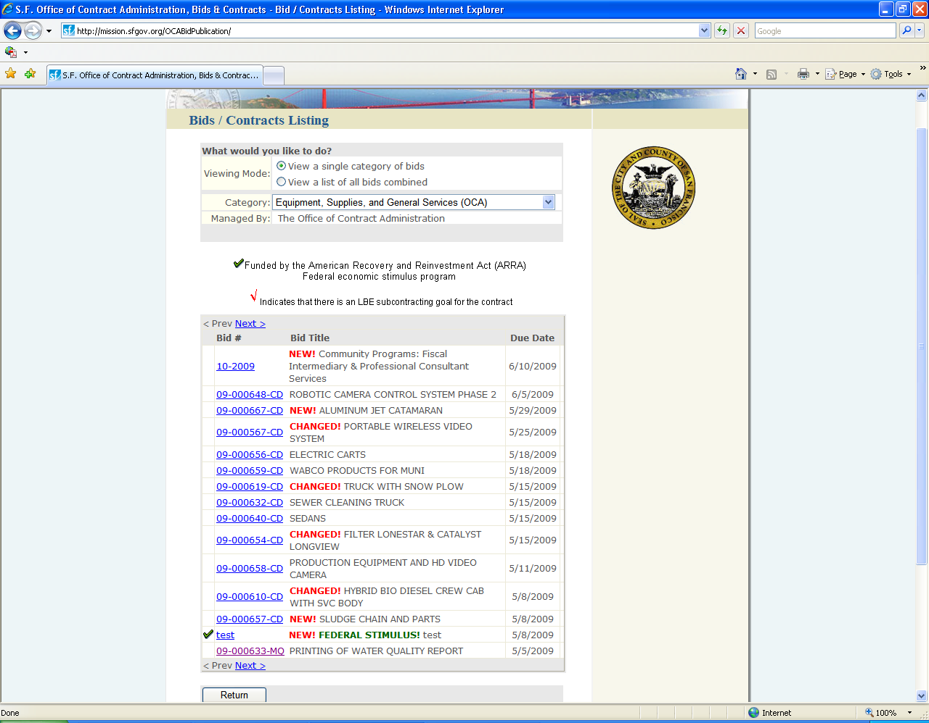

Two things have happened. There’s a green checkmark in a new column on the left, and the words “FEDERAL STIMULUS,” also in green, appear as part of the bid title.

The bid detail has also changed:

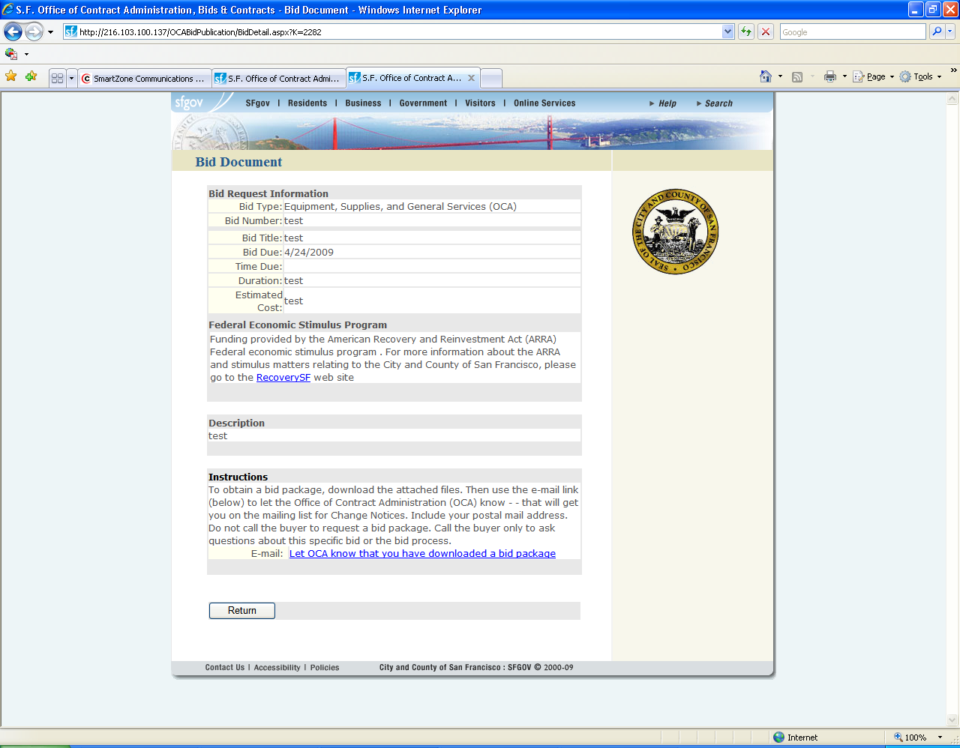

A new “Federal Economic Stimulus Program” area has appeared after Estimated Cost and before Description. The new text says this:

Funding provided by the American Recovery and Reinvestment Act (ARRA) Federal economic stimulus program . For more information about the ARRA and stimulus matters relating to the City and County of San Francisco, please go to the RecoverySF web site.

And one more thing happens automatically. The database has a new category of bids, “Federal Stimulus bids” category. The category is a derived category, populated by copies of Federal Stimulus bids elsewhere in the database. You create your bids normally, assigning them to the normal category. In fact, the Federal Stimulus Bids category does not appear on the data entry screen’s drop-down list of categories.

Here’s a screen shot of how the new category displays to the public.

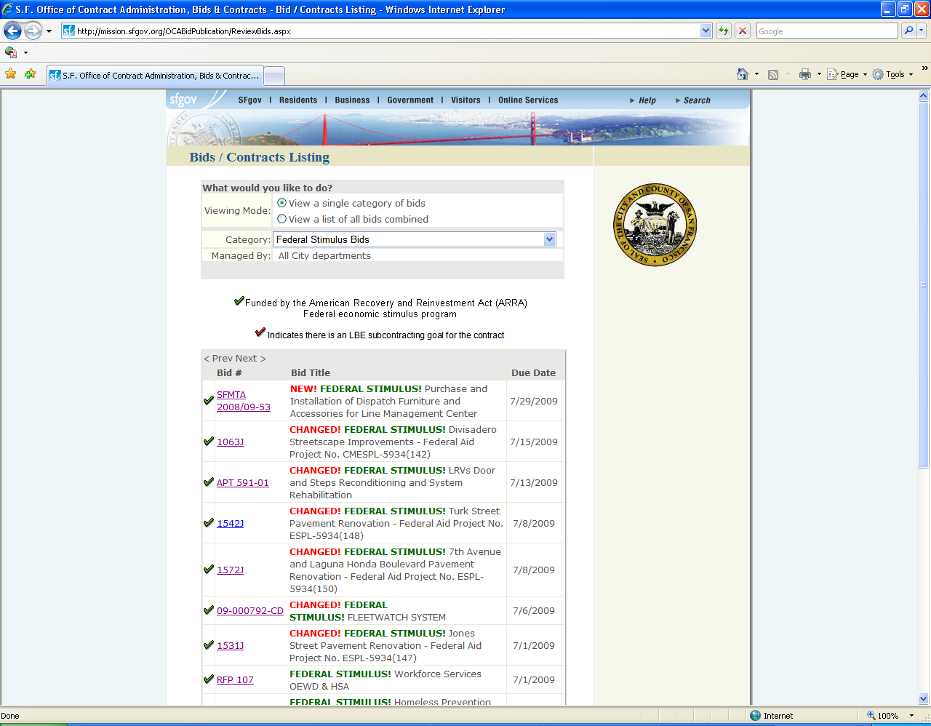

When you modify a bid, the modifications appear automatically in the Federal Stimulus Bids category.
How to modify a bid

At the main menu, select MAINTAIN an existing bid document, comme ça:

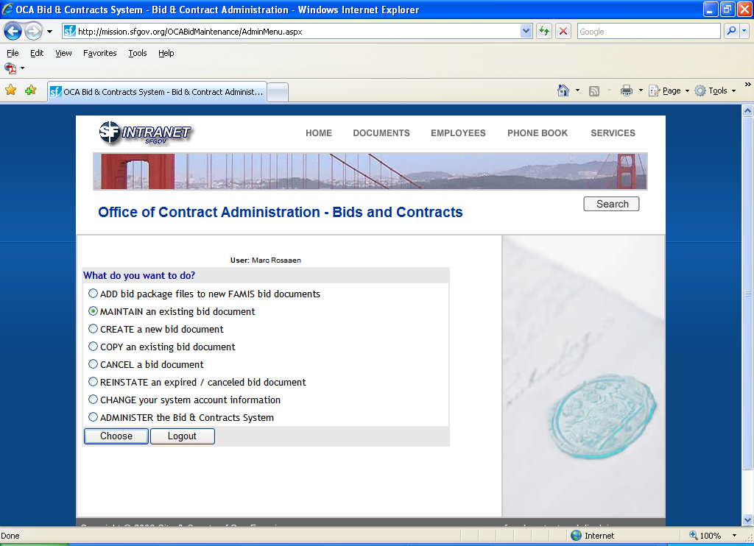

This screen appears:

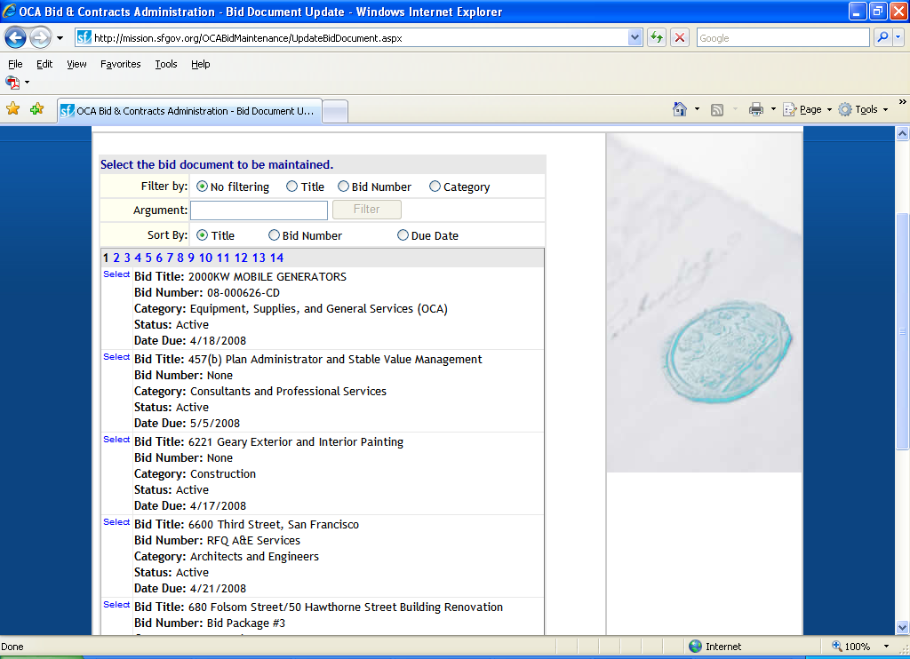

Now all you have to do is find the bid you want to modify.

You’ll see that the system defaults to sorting the list by Title, with numbers sorting before letters. If you click on Sort By: Due Date, the system sorts in reverse order, with due dates in the next decade listed first, and then working down to today.

Using the “Filter by” feature, you can search by a word in the Title, the Bid Number, or the Category. Searching is pretty intuitive.

When you find the bid you want to change, click Select.

This screen appears:

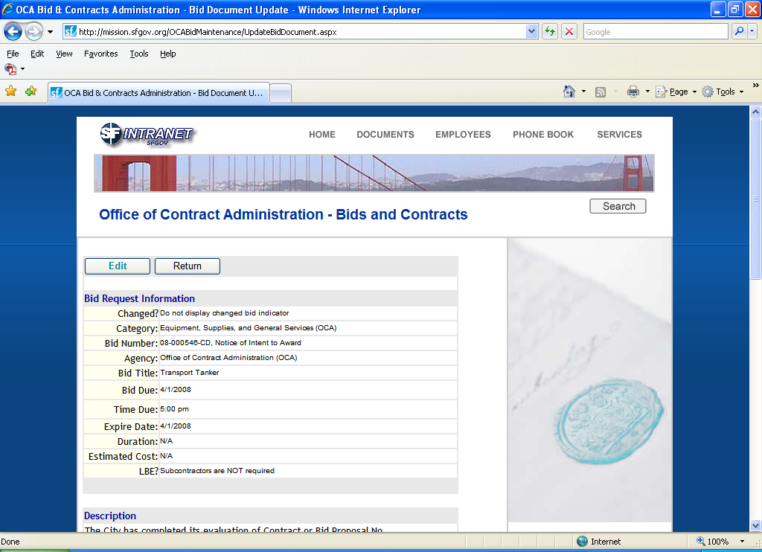

You can review the bid to see if it’s the one you want to change. If it is, click “Edit.”

The screen changes to this:

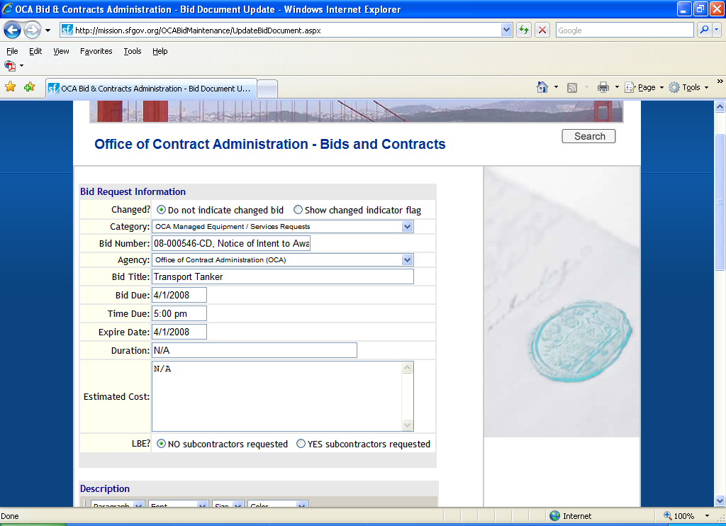

You can change anything you like. Purchasing strongly recommends that if you make a change that isn’t trivial, then in the “Changed?” item at the top you select “Show changed indicator flag.” That causes the word “CHANGED” to appear in the main bid listing. That tells the reader that the bid was changed since it was created, but it doesn’t say anything about what was changed or when. You do that in the “Description” area.

Purchasing recommends that you describe the change by using a red font and saying something like this:

On April 1, this bid notice was changed to attach the Q&A document from the pre-bid conference.

On April 1, this bid notice was changed to post a revised RFP.

On April 1, this bid notice was changed to change the Bid Due Date from Halloween to St. Swithin’s Day.

When you’re done, click Submit.
When prime contractors want to solicit potential LBE subcontractors

The City’s LBE Ordinance requires potential prime bidders to make efforts to solicit LBEs as potential subcontractors. This applies if the bid or proposal has LBE subcontracting goals. HRC has instructed potential primes to ask the City to post their interest in LBEs on the bid database.

Refer to the screen shot on page 3. To the question “LBE?”, if you click “YES, subcontractors requested”, then a field appears and defaults to the e-mail address for your department. You may change it. That is the address that potential prime bidders will use to notify the City of their interest in obtaining LBE subs for the project.

When the bid is posted, bidders will see the following:

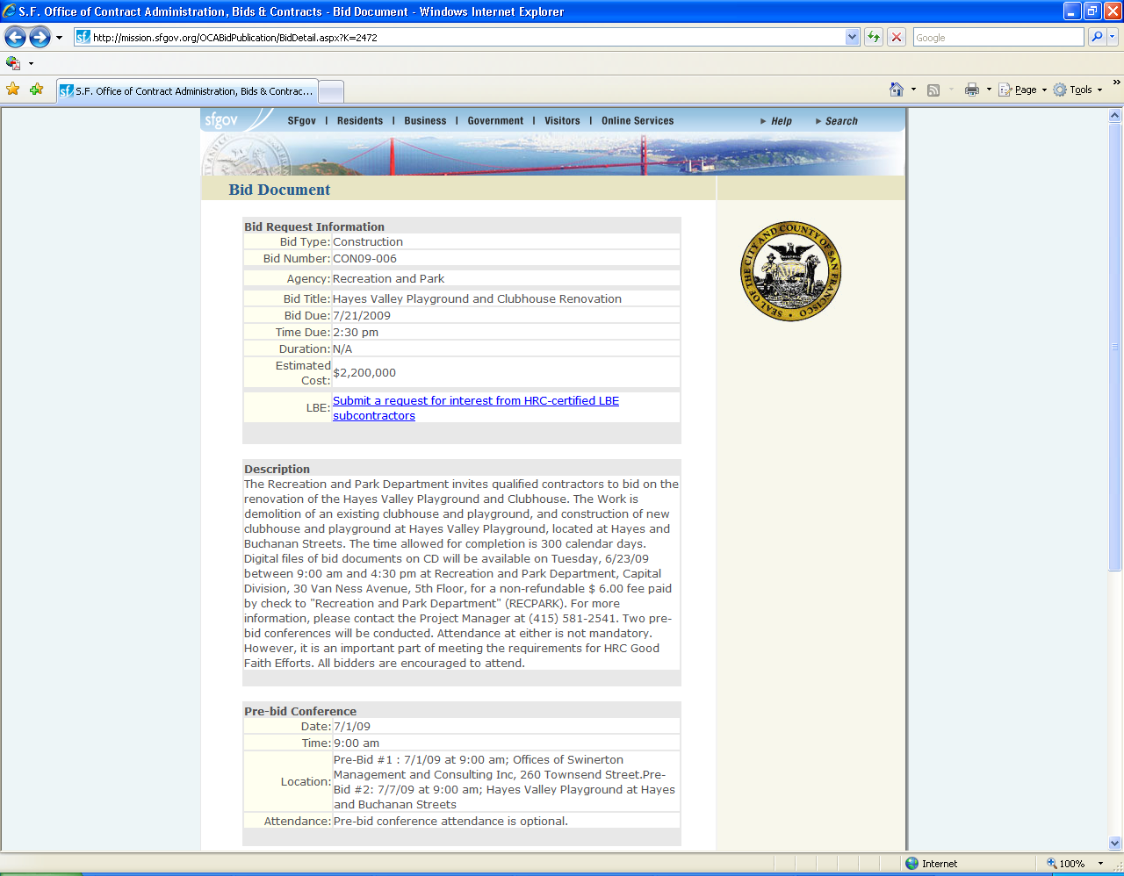

In blue appears “Submit a request for interest from HRC-certified subcontractors.”

When a bidder clicks on that language, this screen opens up:

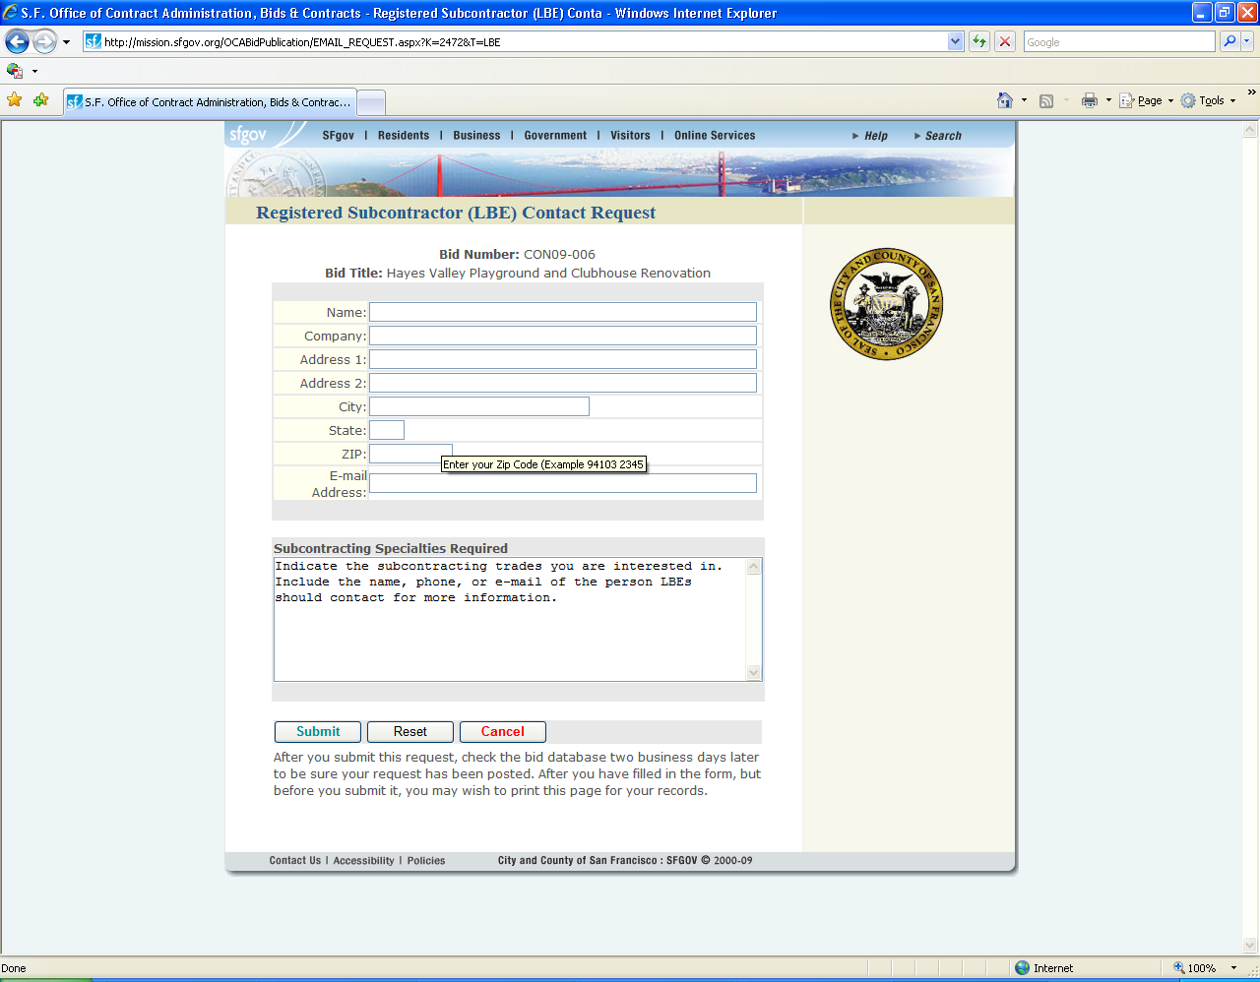

The bidders fill in the fields and click Submit. The system sends an e-mail to the address you specified in the LBE field at time of data entry. If the bidder has filled out the form right, you should have all the information you need to add that bidder’s statement of interest to the Bid Description.

Searching for expired bids

If you’re wondering about a past bid, here’s how to look for it.

At the main menu, select “REINSTATE an expired/canceled bid document.”

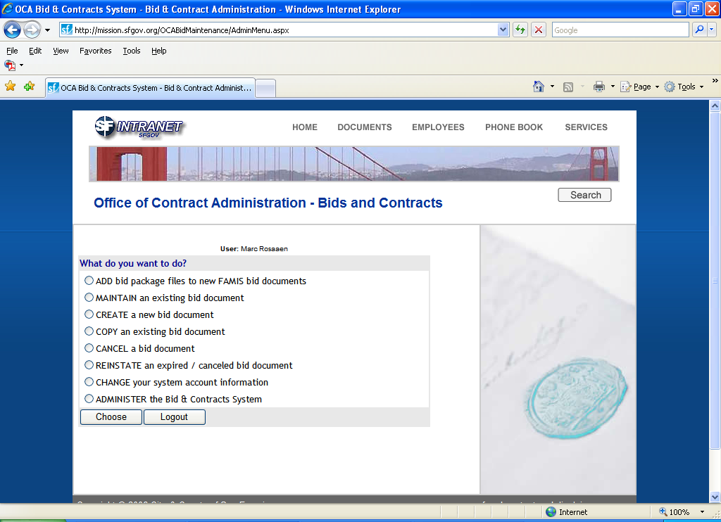

Click “Choose.”
You’ll see this screen next:

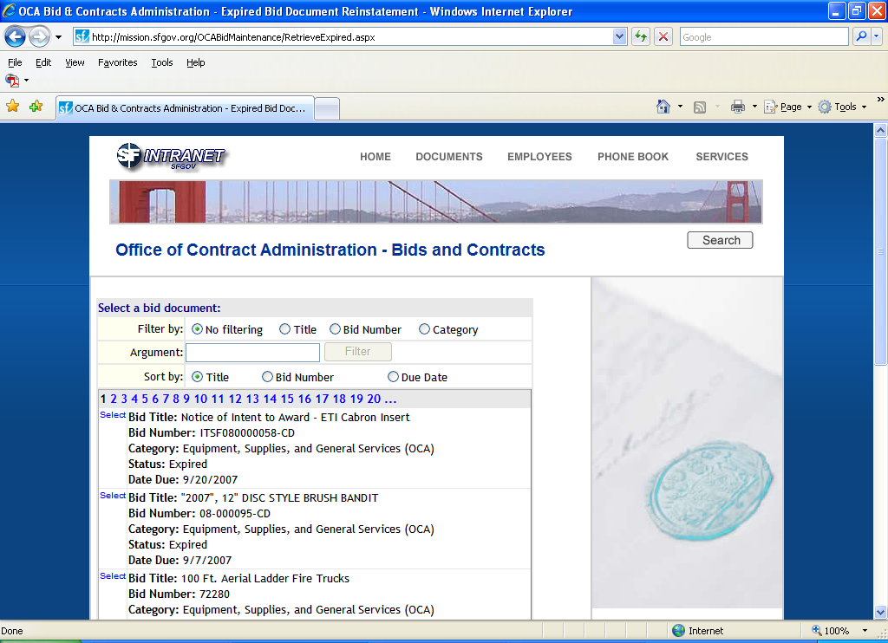

The system defaults to showing you all the inactive bids that have ever been posted by your department. It sorts them by Title. Except I can’t explain why the first bid you see starts with “Notice.” This bid should be in the N’s, but it isn’t. It’s a mystery. The system sorts numbers before letters, and quotation marks before numbers.

If you’re looking for a bid posted by another department, you won’t be able to find it. Call Purchasing and we’ll help you.

If you know the bid number, the bid title, or the bid category, you can search that way. For example, in the “Filter by” area you click Title. In the “Argument” area you enter “sidewalk.” Then click Filter. The system shows you all bids with “sidewalk” in their titles. It’s not case-sensitive. (Filtering by Bid Category probably wouldn’t help much, because each category has had a lot of bids in it.)

See next page.

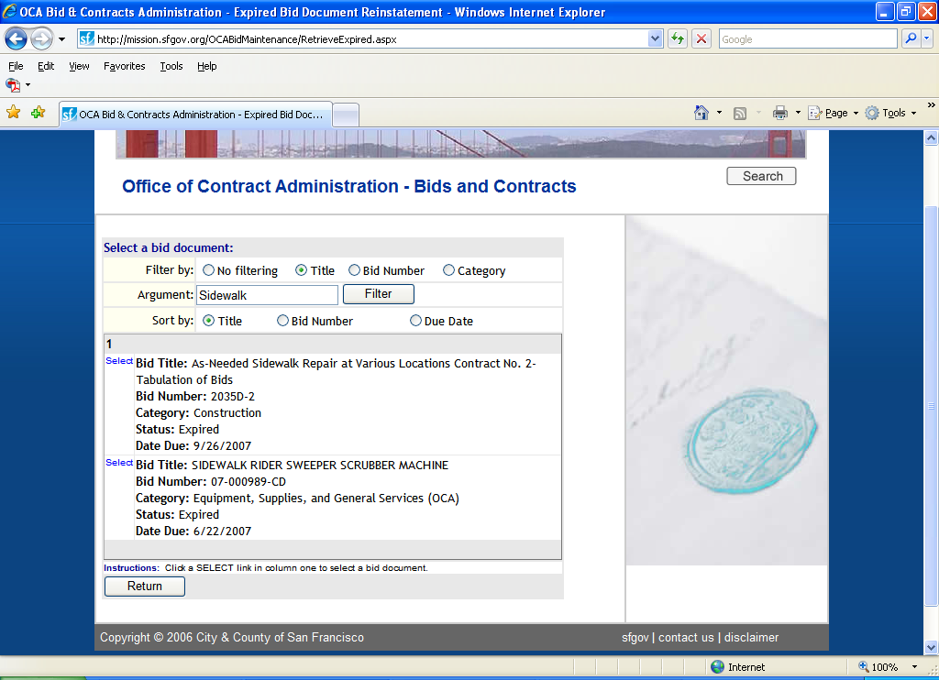

There are two bids with “sidewalk” in their names.

If you don’t want to search like that, then don’t use the Filter. Instead, have the system sort by Title, Bid Number, or Due Date, and go from page to page looking for the bid you’re after. Each screen lists twenty pages of bids, with an ellipsis at either end indicating there are higher-numbered or lower-numbered pages of bids. Unless your department has posted more bids than I think it has, there won’t be more than twenty pages of bids.

Click Select on the first bid on that screen, and you’ll see the screen on the next page.

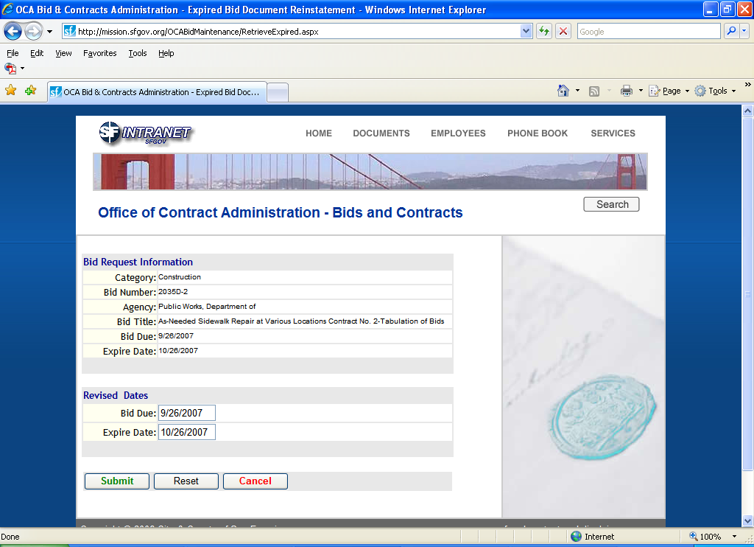

If you want more information that appears here – such as looking at attachments – you’ll have to reactivate the bid for a few minutes to look at it. To do that, click Submit. It’s now back on the net. To look at the rest of its information, go back to the Main Menu and select Maintain an existing bid document. Once you’re done, return to the Main Menu and select Cancel a bid document. You’ll get a big red warning saying if you cancel it, then it won’t be available to the public. They’ll get over it. Click Submit and the bid goes back to its expired status. If you don’t Cancel it, it will disappear at 11:59 p.m. the day you reinstated it.

If you want the bid to stay on the net for a while, then change the Expire Date to the appropriate day. But you have to use a two-digit year, even though it displays a four-digit year.

*

Note about cancelling a bid

Just a friendly tip. If you cancel an active bid, it goes into the archive of bids that have expired or been cancelled. You haven’t deleted the bid from the database. In fact, you cannot do that. It’s always in there somewhere. If, as you’re creating a new bid, you Cancel the process before you Submit the bid, then no record is created in the database.
Error messages

If you exceed the Description area's 7,000-character limit

When you click Submit on a new bid, you might get a warning that you've exceed the 7,000-character limit on how much text you can put in the Description area. Silly you. But you probably didn’t do that. Here's what the problem usually is. If you've pasted text from Word, especially Word 2007, you've also pasted formatting codes that you can't see and they are the cause of the problem. To fix the problem, try this:

- Delete everything in the Description area.
- Go back to the Word document you pasted from, and save it as a text file. Close the file.
- Open the file and copy-and-paste the text again into the Description area. Click Submit.

That should fix it.

But if you really have put more than 7,000 characters in the Description area, then I recommend moving all the text into a new attachment. You might call it "Project description," or something similar.

If the attachment is too large

If you try to attach a file that's bigger than 6 megs, you'll get this message:

Selected file is too large (> 6.00 Mb. limit)!

Do what you can to make the file smaller, such as:

- Compare Word and pdf versions of the file you attached and use the smaller file.
- Cleave the file in twain (or even in thirds) to create smaller files.
- As a last resort, don't attach the file. Instead, put a note in the Description that the file is available and you'll e-mail it upon request.

