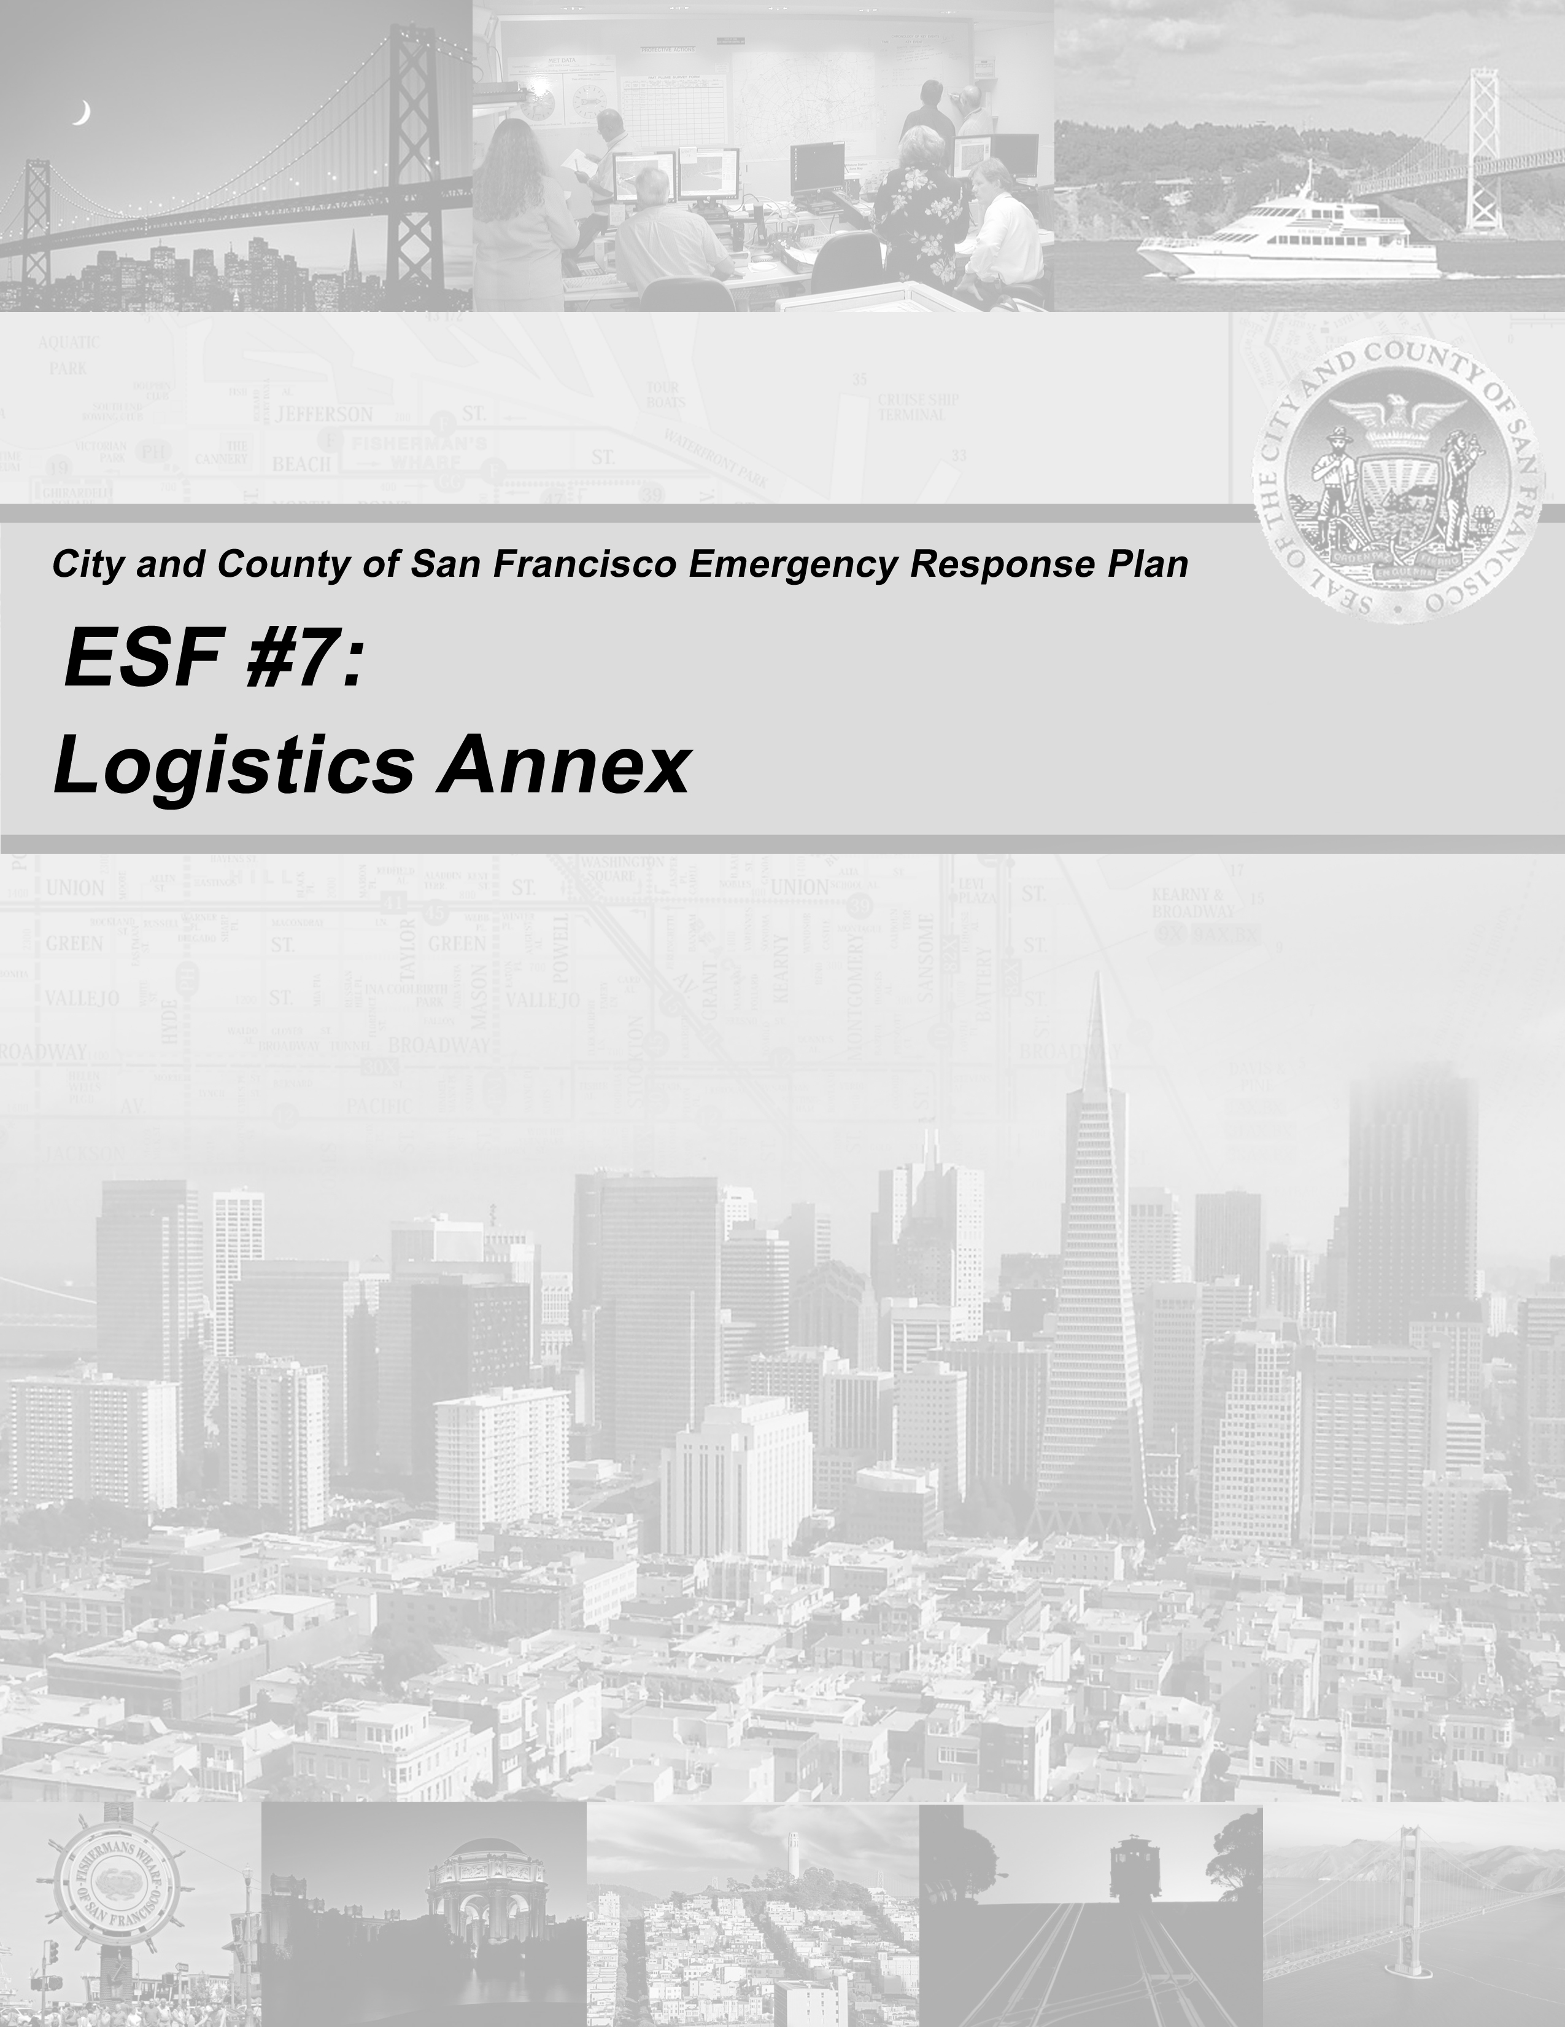

Contents

FOREWORD
Process Flowchart – Anticipated Event iii
Process Flowchart – Unanticipated Event v

Section 1: Introduction 1
1.1 Coordinating and Supporting Departments 1
1.2 Overview of Department Responsibilities 1
1.3 Purpose 2
1.4 Scope 2

Section 2: Concept of Operations 3
2.1 General Concepts 3
2.2 Organization and Structure 3
2.3 Logistics Primary Roles 4
2.3.1 Incident Command Posts (ICPs) 4
2.3.2 Departmental Operations Centers 4
2.3.3 EOC Logistics Section 5
2.3.4 Supporting Roles 8
2.4 Notification and Activation 9
2.4.1 Notification 9
2.4.2 Activation 9
2.5 Response Actions 11
2.6 Deactivation Procedures 15

Section 3: Policies and Guidelines 17
3.1 General Policies 17
3.2 Resource Management Principles 18
3.2.1 Identifying Logistics Requirements 18
3.2.2 Resource Inventory Guidelines 18
3.3 Contracting and Procurement Guidelines 19
3.4 Facilities Guidelines 20
3.5 Disaster Service Worker Guidelines 21
3.6 Donations Management 21

Section 4: Planning Assumptions 23
4.1 Order of Precedence 23
4.2 Plan Development and Maintenance 23

Appendix: List of Abbreviations and Acronyms 25

ATTACHMENT A: EOC Logistics Section Activation Checklist 27
ATTACHMENT B: EOC Resource Order Checklist 29
ATTACHMENT C: ICS-260 SFEOC Resource Order Form 31
ATTACHMENT D: Resource Order Tracking Log 33
ATTACHMENT E: Materials Management 101 35

TABLES
Table 2-1: Scalable Activation 10

FIGURES
Process Flowchart – Anticipated Event iii
Process Flowchart – Unanticipated Event v
Figure 2-1: ESF #7 Organization 4
Figure 2-2: EOC Logistics Section Organization 5
Figure 2-3: Resource Request Mutual Aid Guide 14

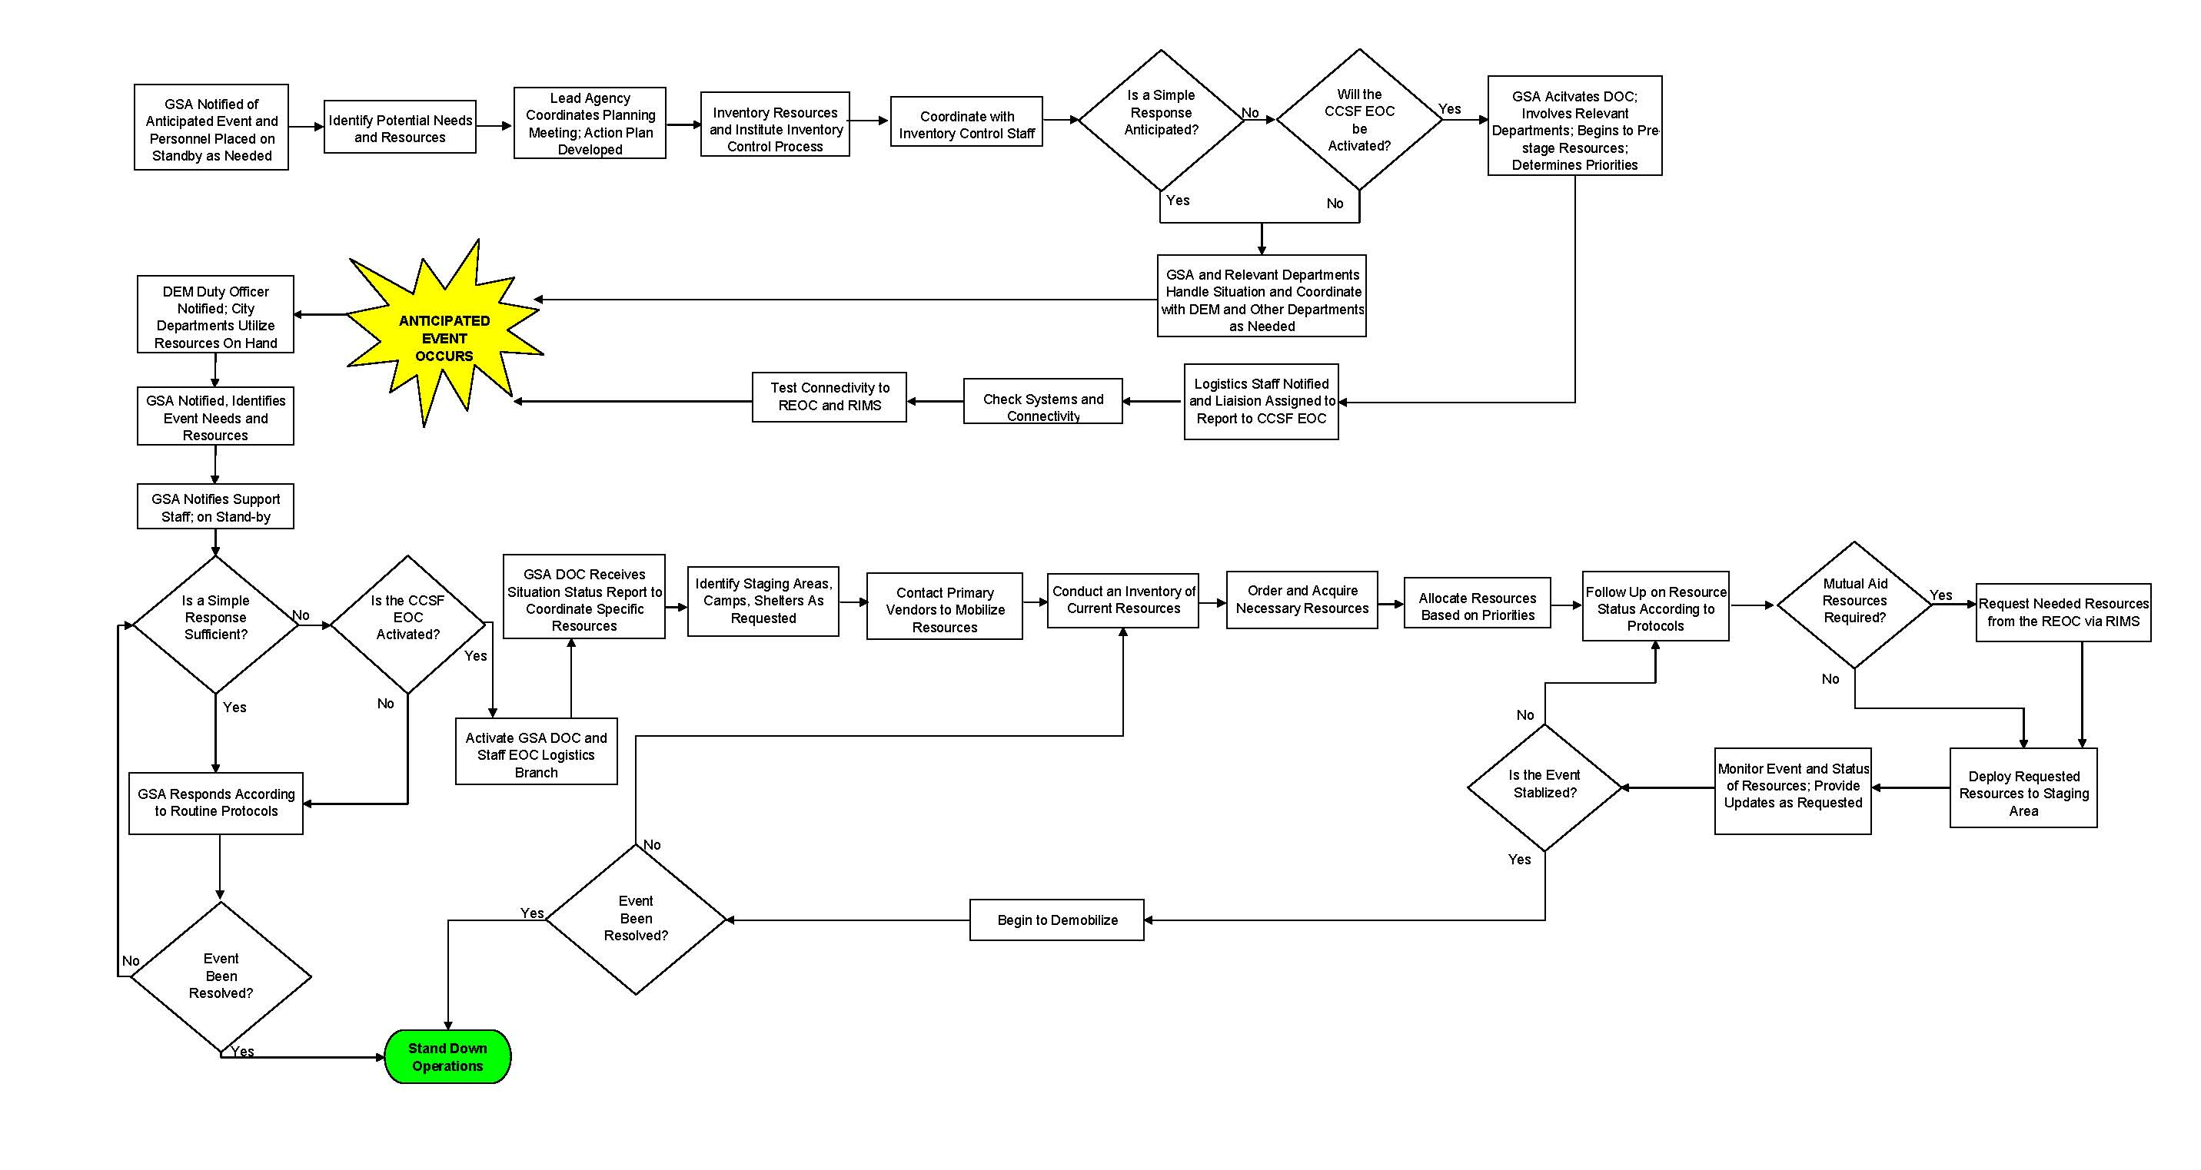

Figure A: Anticipated Event Process Flow Chart
Figure A: Anticipated Event Flow Chart

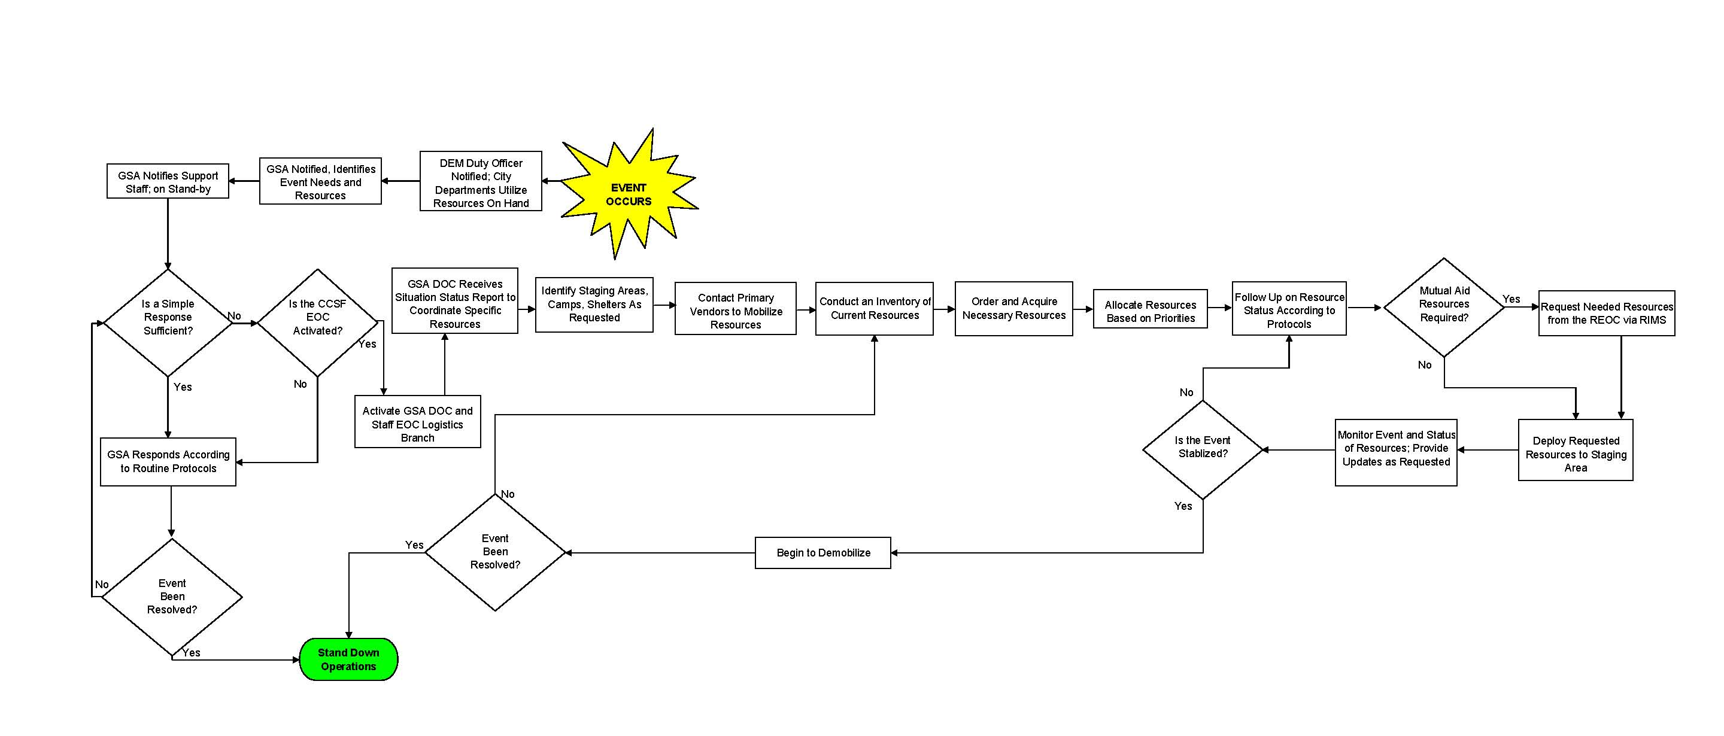

Figure B: Unanticipated Event Flow Chart

Figure B: Unanticipated Event Process Flow Chart

Introduction

Coordinating and Supporting Departments
Coordinating Department | GSA
Supporting Departments | DEM, DHR, GSA: Real Estate, OCA, Central Shops

Overview of Department Responsibilities
Department | Responsibilities
GSA | - Assign ICS positions, as required, in the EOC Logistics Section. This includes DOC and EOC Logistics Section Chief, Deputy Section Chief, Branch Coordinators, and Unit Leaders  - Receive and review Resources Orders in the EOC.  - Obtain resources that cannot be provided by EOC Operation Sections, DOCs or other departments.  - Collect projected resource needs from the EOC sections to develop pro-active resource ordering strategies.  - Oversee acquisition and allocation of scarce resources.  - Coordinate with the EOC Plans and EOC Finance and Administration Sections to ensure EOC resource acquisition and issuance are documented for reimbursement.  - Initiate non-discipline-specific mutual aid to supplement resources (e.g., personnel, equipment, and supplies) as requested.
DEM | - As a Deputy Section Chief, coordinate mutual aid resource requests and act as a main conduit for mutual aid resources.
DHR | - Coordinate DSW and volunteer resources for emergency response.
GSA/Real Estate | - Coordinate provision of adequate essential facilities for the response effort, as requested.
GSA/Office of Contract Administration | - Coordinate and purchase needed resources.
GSA/  Central Shops | - Coordinate the allocation of fuel resources, maintenance, and repair of City vehicles and direct fleet management.
All Supporting Departments | - Establish DOC Logistics Sections and department emergency resource management procedures and protocols, including inventory control, procurement, tracking, mobilization and demobilization.

Purpose
Emergency Support Function (ESF) #7: Logistics provides guidance for coordinating resources needed to support planned events, emergency response, and recovery operations. ESF #7 expands on the City and County of San Francisco (CCSF) Emergency Response Plan (ERP) by providing additional information regarding management structure, processes, and protocols involved in identifying, requesting, ordering, acquiring, mobilizing, tracking, and reporting resources.

Scope
The Logistics Annex provides a framework for the interaction between the EOC and DOC Logistics Sections in San Francisco, as well as guidance for the DOC Logistics Sections when the EOC is not activated.

ESF #7 primarily addresses protocols, processes, and systems for requesting resources that are outside the standard practices of pre-existing discipline-specific (e.g., law enforcement, fire, medical) mutual aid agreements. The guidance provided in this annex is based on the principles of the National Incident Management System (NIMS) Resource Management Processes and the CCSF-specific principles in the following areas:
- Identification of Logistics Requirements
- Inventory of Resources
- Ordering and Acquiring Resources
- Mobilizing Resources
- Resource Tracking and Reporting
- Recovery and Demobilization
- Reimbursement
- Certification and Credentialing
- Training and Exercises

Concept of Operations

General Concepts
The San Francisco General Services Agency (GSA) and supporting departments will use the ESF #7: Logistics Annex to coordinate response actions during an emergency event. Procedures pertaining to this function do not pre-empt or nullify existing GSA functions as they operate within the Incident Command System (ICS).

ESF #7 is one component of a comprehensive, citywide emergency management program. Therefore, this annex incorporates a blend of protocols to maintain compliance with Federal and State planning guidelines and local practices that follow NIMS, the State Emergency Management System (SEMS), and ICS principles.

During a San Francisco Emergency Operations Center (EOC) activation, the EOC Logistics Section supports ESF #7 in coordination with the EOC Operations Support Section. Absent an EOC activation, the Departmental Operations Center (DOC) Logistics Section will support ESF #7. This Concept of Operations outlines the following elements of the Logistics function:
- Organization and Structure
- Logistics Primary Roles
- Notification and Activation
- Response Actions
- Deactivation Procedures

Organization and Structure
ESF #7 is supported by all levels of the emergency response starting with the Incident Command Post (ICP) to the EOC Logistics Section.

The guiding principle of ESF #7 is for DOCs and/or responding departments to utilize all internal resources, including inventories on hand and procurement processes from their vendors, before escalating requests to their supporting EOC branches and sections.

EOC
Manager
Logistics

Plans

Operations

Finance and Administration

Department
Operation
Center

DOC
Logistics
Incident
Command Post

Figure 2-1: ESF #7 Organization

Logistics Primary Roles

Incident Command Posts (ICPs)
At the ICP, the Incident Commander will be responsible for managing logistics operations in the field and will coordinate resource requirements and requests with the ICP Logistics Chief or DOC Logistics Sections.

Departmental Operations Centers
A DOC is an operational/logistical entity designed to serve as a departmental coordinating body in support of incident management. Its broad function is to maintain internal department operations—e.g., continuity of operations (COOP) and continuity of government (COG)—and, when necessary, to contribute to citywide response through communication and coordination.

All departments participating in an emergency response, in addition to being represented in the EOC, should activate a DOC to facilitate the coordination of department operations and logistics.

As outlined in the following sections, the resources of the department remain the asset of the department as well as a shared asset of the EOC Branch and Section/ESF where it is assigned. Therefore, the department (or DOC, if applicable) is responsible for managing their emergency resources before, during, and after an emergency. Common DOC/department resource management assets include existing supplies and equipment, facilities (including storerooms and warehouses), inventory control functions, procurement functions (staff and vendor relationships), cost accounting and accounts payable procedures and personnel. Where these resources are no longer available, a resource request can be submitted through the DOC to their EOC representative in the EOC Operations Support Section.

DOCs are responsible for initiating requests through their existing discipline-specific mutual aid agreements. In the event that additional resources are needed in support of invoking mutual aid, a resource request can be submitted through the EOC.

EOC Logistics Section
The Department of Emergency Management (DEM) and GSA are responsible for establishing the Logistics Section in the EOC, both before and after a disaster occurs within CCSF. Because life-safety efforts take priority during a response effort, resources will address efforts for life saving and evacuation first, and incorporate the capabilities of supporting agencies to receive essential resources.

The EOC Logistics Section coordinates ESF #7 citywide and encompasses several roles, identified as follows. ESF #7 Position Checklists are found in the EOC Standard Operating Procedures (SOP) Manual.

Logistics Section Chief
(GSA)
Deputy Section Chief
(DEM)
Supplies and Equipment Branch
(GSA/OCA and Central Shops)

Facilities Branch
(GSA/Real Estate)

Human Resources Branch
(DHR)

Request Tracking
Unit Leader
(GSA/OCA)

Procurement
Unit Leader
(GSA/OCA)

Figure 2-2 EOC Logistics Section Organization
Logistics Section Chief: Functioning within the EOC Logistics Section, GSA assigns a Logistics Section Chief who will ensure the following actions:
- Acquire and deliver resources requested by the EOC Operations Support Section.
- Allocate scarce resources consistent with EOC Action Plans.
- Request non-discipline-specific mutual aid resources from the Regional Emergency Operations Center (REOC).
- Record and track the status of resource requests processed through the EOC Logistics Section.
- Coordinate with the EOC Planning Section regarding resource status and requirements for the next operational period pursuant to the ICS Planning “P.”
- Identify bases and camps, as necessary, to maintain sufficient inventories of uncommitted resources.
- Coordinate with the EOC Plans and EOC Finance and Administration Sections to ensure EOC resource acquisitions and issuance are documented for reimbursement.
- Support recovery activities including demobilization, restoration of services, and COG, as directed.
- Review responsibilities of Branch and Unit Leaders as listed below and ensure that required activities are completed in the absence of a Branch Coordinator or Unit Leader.

Logistics Deputy Section Chief: Functioning under the Logistics Section Chief, DEM assigns a Deputy Chief who will have the following responsibilities:
- Coordinate requests for resources that have been depleted and are unavailable from within CCSF.
- Act as a main conduit for Federal, State, regional, and local mutual aid resources.
- Establish and maintain connectivity to the REOC and the Response Information Management System (RIMS).
- Establish and maintain connectivity and communication with the GSA DOC and support offices.
- Coordinate mutual aid resource requests through the REOC via RIMS.
- Coordinate resource-specific public information through the Public Information Officer (PIO) / Joint Information Center (JIC), as requested by the EOC Manager.

During an event and the activation of the EOC Logistics Section, the Logistics Section Chief or Deputy Chief may assume or designate Branch and Unit Leader functions to perform the following responsibilities.
Supplies and Equipment Branch:
- Coordinate the procurement of resources.
- Oversee the procurement and allocation of supplies and materials not normally provided through discipline-specific mutual aid channels.
- Expedite delivery of supplies and material, as required.
- Maintain a system to collect, track, and provide shipment information for resource requests received by the Logistics Section.
- Work with other sections and branches to forecast and identify material and equipment shortfalls and pre-identify vendors and other sources.
- Coordinate with the Finance and Administration Section Chief to manage the collection and maintenance of cost and other procurement data.

Facilities Branch:
- Locate, lease, and support facilities or Staging Areas required to support the disaster response.
- Coordinate the relocation of work space for essential CCSF staff dislocated by the disaster, including relocating or leasing office furniture or equipment and configuring the workspace, as appropriate.
- Support requests to locate and rent or lease alternate locations for the EOC/DOCs in the event that they are forced to relocate due to damage or space limitations. Support environmental and safety standards for those facilities.
- Coordinate pre-occupancy environmental inspections.
- Support feeding and housing requirements as requested.
- Coordinate the provision of adequate essential facilities for the response effort, as requested.
- Ensure acquired buildings are returned to their original state when no longer needed.

Human Resources Branch:
- Coordinate the acquisition, tracking, orientation/training, and support of additional Disaster Service Workers (DSWs), which include CCSF response personnel and convergent volunteers.
- Provide personnel resources in support of EOC and Field Operations.
- Identify and register volunteers.
- Establish a list of DSWs and convergent volunteers based on skills, experience, and certification for DOCs to use for response and recovery efforts.
- Coordinate with appropriate CCSF Department Directors or DOC Managers to re-assign staff to the EOC or other response activities, as needed.
- Receive requests and assign available DSWs and convergent volunteers.
- Assist with the maintenance of staff morale.
- Provide guidance to the EOC Management Staff, Policy Group, and the Board of Supervisors regarding any current or potential union issues that may arise from the reassignment of staff to “out-of-class” tasks during the emergency.
- Ensure that DSWs and convergent volunteers are provided with food and shelter while in the jurisdiction on assignment and other personal support through coordination with Human Services Agency (HSA) and the Department of Human Resources (DHR).
- Document any injuries, accidents, or other personnel-related incident reports.

Request Tracking Unit Leader:
- Launch the Resource Tracking Log and establish Resource Order inbox placement and files.
- Ensure sufficient quantities of ICS-260 SFEOC Resource Order Form are available for all EOC sections.
- Track all ICS-260 SFEOC Resource Orders submitted to EOC and provide/request status reports as directed by the EOC Logistics Chief.

Procurement Unit Leader:
- Collect, organize, and prepare procurement requests for purchasing.
- Coordinate with GSA DOC or appropriate purchasing organization to procure resources and route requests.
- Procure resources in the absence of the GSA DOC activation or GSA Office of Contact Administration (OCA) availability.
- Contact primary vendors to mobilize resources (refer to Term Contracts List in Logistics Resources), such as fuel contractors, supplies and equipment vendors, caterers, and rental companies.
- Notify the Supplies and Equipment Branch Coordinator when common resources are being ordered by various agencies to facilitate consolidated ordering and to monitor scarce resources.

Supporting Roles
All city departments are responsible for emergency resource management and providing ESF#7 support to their DOCs as required by an emergency event. An event requiring activation of the EOC Logistics Section will be supported by the following CCSF Departments: GSA, DEM, DHR, and the following GSA agencies: Real Estate, OCA, and Central Shops. Situational updates, reports, and requests will be coordinated through the Logistics Section Chief with supporting departments so that priorities can be identified that lead to unified response efforts for restoration of CCSF operations. Each supporting department maintains its authority and is responsible for providing resources, personnel, equipment, facilities, technical assistance, and support.

Notification and Activation

Notification
Initially, the EOC Manager or DEM Duty Officer notifies GSA of an event and an EOC activation of the Logistics Section. Alternately, if GSA receives a call first from an agency, a GSA representative contacts the DEM Duty Officer to determine the need for ESF #7 EOC activation.

GSA assigns a Logistics Section Chief who will report to the EOC Logistics Section to assist with ESF #7 activities. This is typically accomplished by telephone contact. Depending on the type of emergency situation, the Logistics Section Chief may function as the lead or request additional staffing to coordinate ESF #7 activities.

The EOC Logistics Section Chief is responsible for designating the following positions:
- Logistics Section Deputy Chief
- Supplies and Equipment Branch
- Facilities Branch
- Human Resources Branch
- Request Tracking Unit Leader
- Procurement Unit Leader

Notification to support agencies can be communicated via phone, e-mail, or AlertSF, and will provide a situation update and reporting instructions prior to arrival at the EOC. The EOC Logistics Section Chief maintains a current list of Branch and Unit Leaders with around-the-clock contact information for emergency response.

Activation
The DEM Duty Officer, GSA, or EOC Manager may activate ESF #7 when an event is anticipated or actually occurring in CCSF. The scope and type of the emergency and the associated response will be determined at the time of activation. ESF #7 activities may occur at the ICP, DOCs, GSA DOC, and/or the EOC Logistics Section depending on the level of activation required.

Elements of ESF #7 activation may begin prior to an official notification from the DEM Duty Officer or EOC Manager when a DOC is activated or GSA is alerted to an anticipated or unanticipated event through a department that requests resource management support. If this occurs, notification to the DEM Duty Officer and/or DEM Director should be timely in order to provide situational awareness to the Mayor’s Office and to determine the need for an EOC activation.

Scalable Activation
ESF #7 operations can be expected to expand and contract based on the category, nature, and magnitude of the event. The type and level of activation is generally based on an event’s resource or staffing requirements. Activation of ESF #7 will be predicated on the following:
- City department resources have been depleted or do not exist or a DOC is no longer able to support the resource needs of an incident.
- Cross-department coordination is required for requested, shared resource allocation.
- There is a need to prevent exhaustion of resources to the ICP, DOC, or EOC emergency response and recovery efforts.
- A sustained response effort is anticipated or occurring.

Table 2-1 illustrates a scalable emergency response activation categorized by event type.

Emergency Situation | Examples | Coordinating Department | Placement of ESF #7 Staff
Anticipated Event  (Simple) | Notification of an event with potential impact on citywide resources | Lead Agency | Lead Agency Department DOC
Anticipated Event  (Complex) | Situation escalates to critical, resulting in multiple ESFs and EOC activation | GSA and DEM | EOC Logistics Section
Unanticipated Event  (Simple) | Notification of an actual disruption or event | Lead Agency | Lead Agency Department DOC
Unanticipated Event  (Complex) | Notification of a large-scale event requiring resources and personnel, involving support agencies and EOC activation | GSA, DEM, DHR and  Mayor’s Office | GSA DOC  DHR DOC  EOC Logistics Section
Table 2-1: Scalable Activation

Response Actions

Step 1: Identify Resource Requirements
The need for resources may be identified at any ICS level and will filter up the chain of command, from ICPs to DOCs. DOCs may allocate available resources in tactical situations in coordination with the ICP Logistics Section Chief. DOCs unable to fill resource requests will submit a resource request to the EOC for fulfillment of that request.

Pursuant to the ICS Planning Process (see ICS 703 Section 4), before submitting a resource request to the EOC Logistics Section, the request must be preceded by an existing mission task determined by the EOC Operations Support Section.

Step 2: Requesting Resources
Resources acquired through a department, department DOC, or EOC Operations Support Section are deployed to the designated Staging Area, without going through the EOC Logistics Section. Resources that cannot be acquired in this manner may be acquired by the following steps, through the EOC Logistics Section:
- The Incident Commander assesses and identifies needs that cannot be filled by department or department DOC.
- The department or department DOC contacts the EOC Operations Support Section.
- The EOC Operations Support Section coordinates resource acquisition and deployment to the staging area (or designated delivery location), prioritizes resource requests, and tracks resources.
- If the EOC Operations Support Section cannot fill the request and follows the resource request ordering process, then the request is sent to the EOC Logistics Section Chief who does the following:
  - Identifies methods to fulfill request
  - Addresses conflicts in resource deployment
  - Reports the status of the request and/or the status resource acquisition if a resource is unavailable
  - Makes a request to Federal or State mutual aid partners

ICS-260 SFEOC Resource Order Form: Resource requests must be submitted to the EOC Logistics Section on a completed ICS-260 SFEOC Resource Order Form. Completed Resource Orders must have as much information as possible in order to ensure the appropriate resource is obtained and delivered to the designated location. ICS-260 SFEOC Resource Order Form also serves as primary documentation for reimbursement.

The EOC Logistics Section reserves the right to reject any incomplete or unclear ICS-260 SFEOC Resource Order Form and will return the form to the originator for proper documentation.
All ICS-260 SFEOC Resource Order Forms submitted to the Logistics Section must be specific resource requests that cannot be filled by other operations branches or DOCs. The Logistics Section does not fill Mission Tasks.

MISSION TASKING VERSUS RESOURCE REQUESTS

Resources are personnel, teams, equipment, facilities, and supplies needed to achieve the identified task.

A mission task is a necessary action identified by the Operations Support Section to fulfill an Operational Objective. For example, “Clear debris from Market Street in two hours.”

Resource requests are specific requests for resources. For example, “Deliver three bulldozers with certified operators delivered to Market and Fourth at 1400 hours.”

The Logistics Section does not fulfill Mission Tasks.

Resource Order Prioritization Guidelines: The assignment of a priority rating to a Resource Order is based on the threat level and time needed to respond.

Threat Level | Time Needed to Response
Priority 1: Life Safety | Immediate: 0–2 hours
Priority 2: Incident Stabilization | Critical: 4–11 hours
Priority 3: Property/Environmental Conservation | Scheduled: 11–24+ hours

Orders for DSW resources should be requested six hours before the DSWs are required to report.

Step 3: Ordering and Acquiring Resources
Resources Orders that reach the EOC Logistics Section will be filled through the following methods.

- Locating Inventories from known sources
- Acquisition through purchasing
- Acquisition from alternate vendors
- Non-discipline-specific mutual aid requests

The primary responsibility of the EOC Logistics Section is to coordinate Resource Orders. Contracting and procurement required to fulfill the Resource Orders will generally occur at the GSA DOC or Office of Contract Administration.

Step 4: Resource Allocation and Prioritization
Resources can quickly go from plentiful to scarce during emergencies. Reactive allocation and prioritization of resources becomes increasingly difficult as this occurs. When a resource is scarce and/or when departments cannot agree on proper allocation, the EOC Logistics Section will coordinate the priority and assist with a solution.

Monitoring Resources: The EOC Logistics Section will collaborate with the EOC Planning Section to monitor resource levels and demands through the Operations Support Section branches and by using resource request tracking and standard ICS forms. Through monitoring, the EOC Logistics Section will work with the EOC branches to mitigate resource scarcity. Common scarce resources may include fuel, batteries, radios, and paper and sanitation supplies as well as food, water, and shelter for DSWs.

Scarce Resource Allocation: When a resource becomes scarce such that requests must be prioritized, or when a resource is in high demand because it is deemed critical to resolving the emergency, the EOC Logistics Section will coordinate with the Policy Group, EOC Manager, and Operations Support Section Chief to establish allocation prioritization and a point of contact for that specific resource. When designating a point of contact, the Logistics Section will consider department knowledge, skills, and ability to accomplish the task. The point of contact will be responsible for working with the EOC Logistics Section to ensure availability and distribute the resource based on the prioritization as described above.

Step 5: Requesting Resources from Federal and State Agencies
When an EOC Logistics Resource Order cannot be filled locally or when the resource becomes increasingly difficult to obtain, the EOC Logistics Section will develop a formal REOC Mission Request using information on ICS-260 SFEOC Resource Order Form. The REOC Mission Request is submitted electronically through the REOC RIMS. The REOC then assigns a Mission Coordinator to manage the request.

If the REOC cannot fill the request, the REOC Coordinator may elevate the request to the State Operations Center (SOC) with approval of the REOC Director. The SOC will coordinate resources from unaffected regions within the State and will prioritize resource requests based on overall State and regional objectives and strategies. The SOC may use the Emergency Management Assistance Compact (EMAC) to put a request out to other states. If a Federal declaration is in place, the SOC may also send requests through Federal channels.

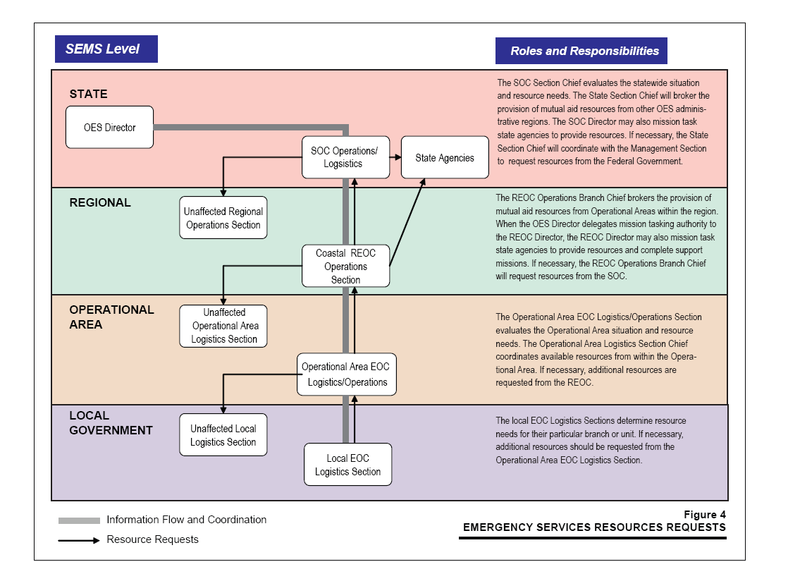

Figure 2-3: Resource Request Mutual Aid Guide

Step 6: Tracking, Reporting and Documentation
The EOC Logistics Section will only track resource requests submitted directly to the EOC Logistics Section an ICS-260 SFEOC Resource Order Form. All other ICS-260 SFEOC Resource Order Forms not submitted to the Logistics Section must be submitted to the Planning Section for tracking. Completed copies of ICS-260 SFEOC Resource Order Forms must be provided to the Logistics, Plans, and Finance and Administration Sections pursuant to instructions on the ICS-260 SFEOC Resource Order Form.

The EOC Logistics Section will track ICS-260 SFEOC Resource Orders that have been received and deemed completed by the Logistics Section. Received Resource Orders will be tracked on a master tracking log spreadsheet managed by the EOC Logistics Section Resource Tracking Unit.

ICS-260 SFEOC Resource Form requests will be tracked from order to fulfillment, primarily focusing on exception tracking when the requestor notifies the Logistics Section that a Resource Order has not arrived as planned. The EOC Logistics Section will not track resources at the Field Level, ICP level, or DOC. The Staging Area Manager will track resources from arrival to departure at the Staging Area.

Step 7: Mobilization and Pre-Staging
Pre-Staging Supplies and Equipment: For all emergencies, the Logistics Section will immediately contact vendor partners to establish communication lines and share information regarding the emergency response requirements. These vendors include, but are not limited to, the following:
- Fuel Suppliers
- Caterers
- Supplies and Equipment Providers
- Rental Companies

Vendors instructed to fulfill purchase orders from the DOCs will call the Logistics Section Chief immediately in the event that a resource becomes scarce.

Staging Areas, Bases, and Camps: GSA maintains a master list of locations for Staging Areas, camps, and shelters in the Logistics Section Facilities Branch. Conflicts with use or assignment of any of these locations must be referred to the Operations Support Section Chief in collaboration with the Policy Group.

Deactivation Procedures
Deactivation of ESF #7 may extend deep into the recovery phase and may involve a transfer of responsibility to Federal and/or State agencies. Deactivation of ESF #7 operations is the responsibility of each responding agency through the activated DOCs and EOC Operations Support Sections. Once deactivation is announced, GSA will conduct the following activities:
- The EOC Logistics Section will work with the Planning Section to support the Demobilization Plan and will perform actions as requested via ICS Form 260.
- Coordinate deactivation steps with supporting departments.
- Ensure all ICS-260 SFEOC Resource Order Form documentation submitted to the Logistics Section and the master tracking log spreadsheet are given to the Documentation Unit in the Planning Section at the completion of demobilization.
- Debrief staff and conduct an after action meeting.

Policies and Guidelines

General Policies
General ESF #7 policies and guidelines are as follows:
- The resources of a department remain the asset of the department as well as shared resources of the DOC and the San Francisco EOC section/branch/division under which the department is assigned.
- Each responding entity must exhaust/maximize its own internal resources, including inventories on hand and pre-approved procurement processes, with its contractors and vendors before escalating requests to the next supporting level listed in ascending order (e.g., field, ICP, DOC, EOC, REOC, SOC, and Federal Emergency Management Agency [FEMA]).
- Discipline-specific mutual aid related to fire and rescue, health, and law enforcement shall be invoked by the responsible department pursuant to established agreements.
- Non-discipline-specific mutual aid requests for Federal and State resources are submitted on a completed ICS-260 SFEOC Resource Order Form to the EOC/Logistics Section.
- Departments maintain delegated purchasing authority during an emergency.
- All purchases from contractors and vendors required for the response shall be recorded in the citywide accounting and purchasing system, (Financial Accounting and Management Information System [FAMIS] / Advance Purchase Inventory Control System [ADPICS]), either at the time of ordering or retroactively if the system is unavailable during an event.
- Purchases shall be documented using the ICS-260 SFEOC Resource Order Form.
- GSA OCA / Purchasing staff shall be assigned to the department’s DOC Logistics Section to which they are normally assigned.
- Mission Tasking is the dispatching of personnel outfitted with the necessary supplies and equipment to complete a task or assignment. This differs from a Resource Order, which is used to order resources such as supplies, equipment, facilities, and personnel in support of and supervised by those responsible for operational objectives and assigned tasks.
- The Logistics Section, Human Resources Branch will only coordinate DSWs who are not assigned to existing DOCs, pursuant to department response plans.
- Requests for DSW resources should be submitted six hours prior to the DSWs’ reporting time.
- Receipt and distribution of unsolicited donated items are not the responsibility of the EOC Logistics Section.

Resource Management Principles
Pursuant to NIMS / ICS guidelines, resource management involves coordinating and overseeing the application of protocols, processes, and systems that provide incident managers with timely and appropriate resources during an incident. NIMS defines resources as personnel, pre-identified emergency response teams, facilities, equipment, materials, and supplies. Other resources may include funding sources, pre-designated agreements, policies, and protocols.

The guiding principle of citywide resource management is for department DOCs to utilize all internal resources, including inventories on hand and procurement processes from their vendors, before escalating requests to their supporting EOC branches and sections. This assumes that the ICPs are supported by their respective DOCs.

The resources of the department remain the asset of the department as well as a shared resource of the EOC section/branch/division under which the department is serving in the event response. For example, a DPW bulldozer remains the responsibility of DPW but is a shared resource of the Infrastructure Branch and the Operations Support Section where DPW is assigned.

Identifying Logistics Requirements
The ability to articulate, share, and coordinate information regarding needed resources in advance of and during an event is critical to an emergency response. This information includes knowing what is needed, what is available on hand, what is not available or in insufficient quantities, how to get needed resources from other departments or from contractors and vendors, and how to ask for it from Federal or State agencies. This resource communication loop must be constantly updated by all stakeholders alike and be an integral part of their “Planning P” processes.

Resource Inventory Guidelines
All CCSF departments have systems in place for ordering, managing, storing, issuing, and accounting for materials and supplies required for normal operations. These materials include common items throughout all CCSF departments (e.g., water, paper, batteries) or specialized items used only within certain departments. City departments manage their resources using various systems consisting of paper-driven, manual processes; stand-alone, automated materials management systems; or modules within larger automated systems.

During a major disaster, departments must continue to practice an inventory control process to ensure that adequate supplies and equipment are available to support an emergency response. During a response event, the resource management process often remains the same with the exception of a higher volume of resources and reduced lead time for deployment. Each department’s emergency planners and responders must coordinate with their department inventory control staff to ensure that critically needed items are stocked in sufficient quantities to initiate a response.

As outlined in previous sections, the guiding principle of citywide resource management is for departments/DOCs to utilize all internal resources—including inventories on hand, procurement processes from their vendors, and existing mutual aid channels—before escalating requests to their supporting EOC branches and sections.

Through the planning process during an emergency incident, departments must identify the resources needed to accomplish their mission tasks pursuant to the event objectives. After each department’s emergency planners and responders have identified their resource needs, they should maximize the use of their own material management systems to support the response efforts. As a result of this assessment, departments must determine what they have available as well as what they need, and determine how they will obtain the resources that are not available.

As outlined in the previous sections, departments/DOCs will request resources from the EOC through their ESF representative in the Operations Support Section. (See Attachment E: Materials Management 101 for more information).

Contracting and Procurement Guidelines
The EOC Logistics Section will coordinate Resource Orders and submit procurement requests to the GSA DOC or the OCA Central Office to fulfill those requests. OCA staff assigned to mission-critical departments will remain in their positions to support the assigned department. All emergency purchases must be consistent with FEMA reimbursement guidelines.

Procurement processes and procedures remain in place to ensure that emergency procurement occurs within the parameters of fiduciary responsibility and the best interests of CCSF. These processes and procedures include, but are not limited to, the following:
- Using FAMIS/ADPICS to place orders
- Ordering from Term Contracts
- Assigning Emergency Index Codes to all purchases
- Documenting and tracking all purchases

Waiver of Purchasing Requirements: CCSF Administrative Code Section 21.15 sets forth official emergency purchasing requirements. Upon declaration of an emergency, some purchasing requirements can be waived (e.g., business tax, domestic partner benefits) when lives and property are in danger.

Emergency purchases can be made for commodities and services not designated on the contract, but only purchases less than $100,000 when the purchase is necessary to (1) prevent loss of life, (2) stabilize or mitigate an emergency, and/or (3) protect loss of property.

EOC Logistics Section Purchasing Authority: The Logistics Section may coordinate purchases through the GSA DOC to fulfill resources requests and will assign an appropriate departmental emergency index code to each purchase pursuant to direction from the Finance and Administration Branch (Controller’s Office).

Department Delegated Purchasing Authority: In an emergency, departments/DOCs retain delegated purchasing authority and will exercise that authority to meet the needs of the department’s emergency response activities.

ICP Emergency Purchasing Authority: Responders may purchase a required resource directly from any available contractor or vendor with the approval of the ICP Logistics Section Chief or the Incident Commander.

Facilities Guidelines
Pursuant to NIMS protocols, Staging Areas, bases, and camps are defined as follows:

- Incident Base: An Incident Base is the location at which primary support activities are conducted. A single Incident Base is established to house all equipment and personnel support operations. The ICS Logistics Section, which orders all resources and supplies, is also located at this base. The Incident Base should be designed to be able to support operations at multiple incident sites.

- Camps: Camps are separate from the Incident Base and are located in satellite fashion from the Incident Base where they can best support incident operations. Camps provide certain essential auxiliary forms of support, such as food, sleeping areas, and sanitation. Camps may also provide minor maintenance and servicing of equipment. Camps may be relocated to meet changing operational requirements.

- Staging Area: Staging Areas are established for temporary location of available resources. The Operations Support Section Chief establishes Staging Areas to enable positioning of and accounting for resources not immediately assigned. A Staging Area can be any location in which personnel, supplies, and equipment can be temporarily housed or parked while awaiting operational assignment. Staging Areas may include temporary feeding, fueling, and sanitation services. The Operations Support Section Chief assigns a manager for each Staging Area, who checks in all incoming resources, dispatches resources at the Operations Support Section Chief’s request, and requests Logistics Section support, as necessary, for resources located in the Staging Area. Personnel check in with the Resources Unit at the Staging Area, while supplies and equipment are checked in with the Supply Unit. If neither of these functions are activated, resources report to the Staging Area Manager for direction.

Disaster Service Worker Guidelines
The Logistics Section Human Resources Branch is responsible for coordinating deployment of all employees in departments who are not committed to existing DOCs pursuant to the citywide Emergency Response Plan and department/DOC response plans. Requests for DSW resources should be submitted six hours before the required DSW resources are required to report.

Donations Management
The EOC Logistics Section can designate a staging location and attempt to procure DSW support, as requested by the EOC Operations Support Section. The EOC Logistics Section does not manage, receive, or distribute donated goods. The donations management process shall be addressed and coordinated pursuant to the CCSF Donations Management Plan. A responsible agency or CCSF department must be designated as the Staging Area Manager for Donations Management.

.

This page is intentionally blank.

Planning Assumptions

Order of Precedence
The specific roles, responsibilities, procedures, actions, and polices outlined in the Emergency Support Function #7: Logistics annex expand on the guidelines in the City Emergency Response Plan (ERP). In the event that a discrepancy exists between this annex and the ERP, the plan with the most recent revision date will supersede.

Plan Development and Maintenance
The ESF #7: Logistics Annex will be reviewed and updated annually by a Logistics Section Annex Sub-Committee of the Emergency Resource Planning Workgroup (ERPW). Sources of annual review include internal policy reports and procedure review, exercises, and real emergencies.

All designated Logistics Section staff, as well as other responsible agents within other incident command sections, will receive annual training of the annex through discussion-based exercises (seminars, workshops, and/or tabletops) and/or operations-based exercises (drills, functional exercises, and/or full-scale exercises) as dictated by the citywide, comprehensive exercise program or on an ad hoc basis by the Logistics Section.

This page is intentionally blank.

Appendix: List of Abbreviations and Acronyms
The following abbreviations and acronyms are used in this annex:
ADPICS | Advanced Purchase Inventory Control System
CCSF | City and County of San Francisco
COG | Continuity of Government
COOP | Continuity of Operations
DEM | Department of Emergency Management
DHR | Department of Human Resources
DOC | Department Operations Center
DPH | Department of Public Health
DSW | Disaster Service Worker
EMAC | Emergency Management Assistance Compact
EOC | Emergency Operations Center
ERP | Emergency Response Plan
ERPW | Emergency Resource Planning Workgroup
ESF | Emergency Support Function
FAMIS | Financial Accounting and Management Information System
FEMA | Federal Emergency Management Agency
GSA | General Services Agency
ICP | Incident Command Post
ICS | Incident Command System
JIC | Joint Information Center
NIMS | National Incident Management System
OCA | Office of Contract Administration
PIO | Public Information Officer
REOC | Regional Emergency Operations Center
RIMS | Response Incident Management System
SEMS | Standardized Emergency Management System
SFEOC | San Francisco Emergency Operations Center
SFFD | San Francisco Fire Department
SFPD | San Francisco Police Department
SFSD | San Francisco Sheriffs Department
SOC | State Operations Center
SOP | Standard Operating Procedure

This page is intentionally blank.

Attachment A: EOC Logistics Section Activation Checklist

ACTIVATION LIST

City Administrator
GSA Emergency Team Leader
GSA Emergency Preparedness Coordinator

EOC LOGISTICS SECTION SET-UP

- Once notified by DEM, Section Chief and Branch Managers will report to the EOC.
- Check availability of computer systems (Internet, e-mail, ADPICS, helpbayarea.org, etc.), telephone lines and fax lines.
- Check connectivity to the EOC local area network (LAN) and access to the Logistics Section folder on the DEM U:// Drive.
- Test connectivity to Regional Emergency Operations Center (REOC) and Response Information Management System (RIMS)
- Locate Logistics Section flash drives and distribute to Branch Managers when network is not available.
- Launch the Resource Tracking Log and establish Resource Order Inbox placement and files.
- Ensure sufficient quantity of ICS-260 SFEOC Resource Order Form (“ICS Form 260”) are available for all EOC Sections.
- Check connectivity to Logistics DOCs and support offices.

Department Operation Center | Main Line | METS Line
GSA DOC
DHR DOC | Telephone Numbers  on file at EOC
Office of Contract Administration
Real Estate DOC
Central Shops
City Hall Building Management
Convention and Facilities
Finance and Admin DOC

- Contact primary vendors to mobilize resources (refer to Term Contracts List in Logistics resources)

  - Fuel contractors
  - Supplies and equipment vendors
  - Caterers
  - Rental Companies

This page is intentionally blank.
Attachment B: EOC Resource Order Checklist

Operating in the EOC Logistics Section during an event requires the basic following steps to be adhered to in order to respond effectively:
- Receive and review ICS-260 SFEOC Resource Order Forms from the EOC Sections (Deputy Logistics Chief, Supplies and Equipment Branch Coordinator, Procurement Unit Leader)
- Log completed ICS-260 SFEOC Resource Order Forms submitted to the Logistics Section into the Master Tracking Log (Resource Request Tracking Unit Leader).
- Distribute submitted ICS-260 SFEOC Resource Order Forms to the applicable Logistics Section Branch (Supplies and Equipment Branch Coordinator).
- Take action to fill requests as follows (Supplies and Equipment Branch Coordinator, Procurement Unit Leader, Facilities Branch Coordinator):
  - Send requests to the GSA DOC – Supplies and Equipment (OCA)
  - Check available resources and inventory
  - Procure through existing CCSF contracts and vendors
  - Obtain resources from other sources
  - Submit non-discipline-specific mutual aid requests pursuant to policies.
- Document all actions taken on the Resource Request Log and EOC Activity Log and post periodically to U://Drive (Resource Request Tracking Unit Leader).
- Once processed, distribute copies of completed ICS-260 SFEOC Resource Order Forms to Operations (pink), Finance and Administration (white), and Planning Sections (gold) as instructed on ICS-260 SFEOC Resource Order Form.
- Collect projected resources needs from the Planning Section to develop pro-active resource ordering strategies (Logistics Chief).
- Monitor response actions via radio to anticipate upcoming resource needs (Logistics Deputy Chief).

This page is intentionally blank.
Attachment C: ICS-260 SFEOC Resource Order Form
and Instructions
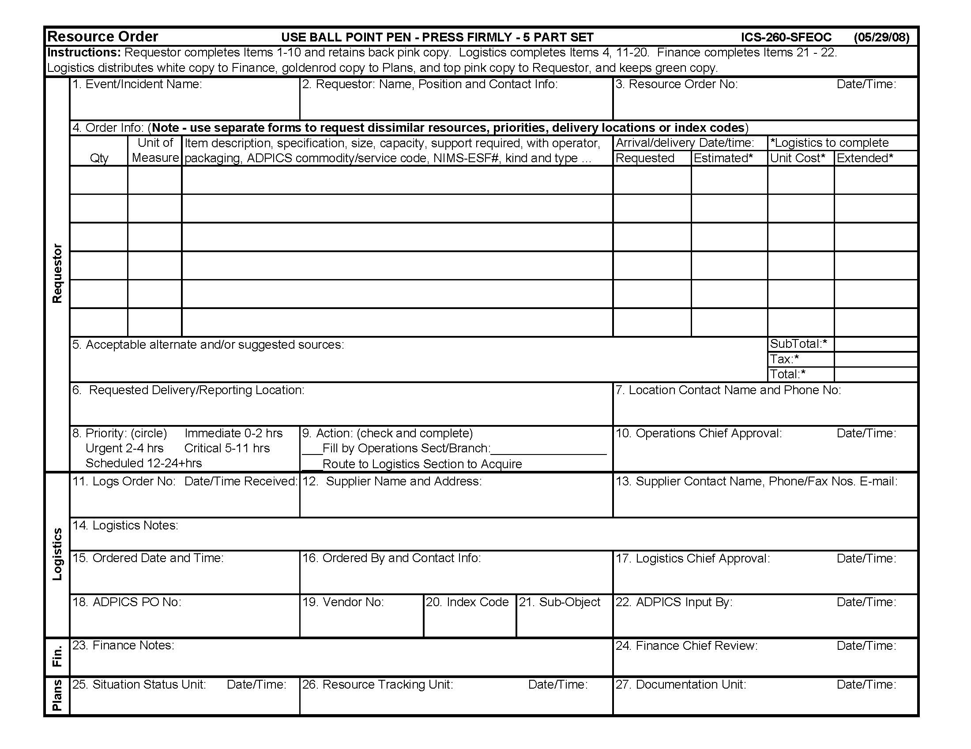

This page is intentionally blank.
Attachment D: Resource Order Tracking Log
Resource Tracking Log is stored on the EOC U:// Drive and the Logistics Resources Flash Drives.

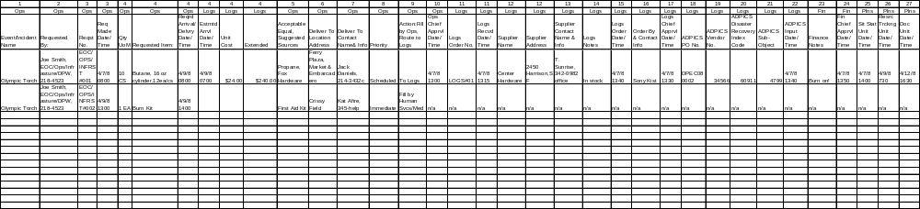

This page is intentionally blank.
Attachment E: Materials Management 101

Emergency Resource Planning and Response Issues:
- Not being able to communicate, share and coordinate resources:
- Not knowing what is needed
- Not knowing what is on hand
- Not having what is needed on hand
- Not having enough of what is needed on hand
- Not knowing how to get what is needed; across depts., from contractors/vendors,
- Not knowing how to get more of what is needed; across depts., from contractors/vendors
- Not knowing how to ask for what is needed from the EOC, State or Feds
- Centralized vs. decentralized emergency resource planning and response
  - Economies of scale (efficiency) vs. control (effective)
  - Under-staff (overwhelmed) vs. over-staff (under utilized)
  - Common vs. specialized resources

Key Elements: Inventory Control Storekeeping/Warehousing
Procurement Cost Accounting/Accounts Payable

Inventory Control:
- Stock vs. non-stock (order as needed) determining factors;
- Common and frequently used items
- Items with a known usage and are difficult to acquire or have long lead time
- Items that are essential to the operation of the department
- Items that are required by laws, regulations or part of build-out/program
- Items that are needed to respond to emergencies/disasters
- Storeroom/warehouse inventories vs. shadow inventories (working stocks)
- Extended supply chain; reasonable vs. unreasonable
- Cost/benefit of an extended or shorten supply chain
- Inventories; General vs. specialized use, Common vs. dedicated
- Physical and financial restrictions as to what and how much to stock
- Inadequate facilities and storage areas; capacity and configuration
- Security is insufficient or too expensive to maintain
- Items are too large or heavy, or too many
- Items are require special handling and/or storage requirements
- Items that grow feet and walk away
- Items and quantities needed are too costly
- Inadequate/insufficient inventory funding
- Increasing prices; technological and inflation
- Obsolete and/or overstocked items ties up space and money
- Inventory Control Systems
  - Eye-ball, manual inventory cards, automated stand-alone and sub-systems
  - Maintain identification numbers for both stock and non-stocked items
  - Record issues, orders, receipts and adjustments; stock number, date, quantity price, source and account code
- Maintaining adequate stock levels
- Inventory; reconcile physical count to book value - annual, cycle & as-needed
- Usage; historical average vs. projected – reactive vs. proactive
- Lead time; from identifying need to reorder and having it available to issue
- Standard deviation; variations for historical usage and lead times.
- Safety Stock; on-hand quantity at all times to avoid out-of-stock, meet minimum requirements and to respond to emergencies
- Inventory stratification; ABC based on usage, cost, importance
- Inventory policies; turns, minimum and maximum
- Turn; n = issued/purchased, or issued/(# of purchases x constant)
- Minimum/ROP-Reorder point, qty = lead time + standard deviation + safety stock
- Maximum/EOQ-Economic order quantity, qty = turn + minimum – safety stock
- Recognize and adjust for seasonality, cycles, trends and market conditions
- Purge obsolete and overstocked inventories

Storekeeping
- Receive;
- Check and sign for correct items and quantities ordered and any damages
- Remedy any discrepancies with vendor
- Process non-stocked purchases for delivery to requestor
- Process inventoried purchases for stocking
- Clear purchase and delivery orders, and packing lists for posting and payment
        - Stock;
- Maintain stocking schema based on storage requirements and issuing patterns
- Rotate stock; first in-first out
- Break down bulk quantities as needed to stock locations, shelves and bins
- Label items and stock locations to ease/expedite identification
- Record location of overage if not stored at assigned location
        - Issue;
- Fill requisitions for stocked items
- Pull stock using first in-first out
- Process filled requisitions for inventory posting
- Assist Inventory Control with identifying obsolete and overstocked inventories
        - Physical Inventory; assist in as-needed and scheduled
        - Document and report damaged, lost or stolen inventories
        - Operate and maintain material handling equipment; forklifts, pallet jacks, dollies…
        - Maintain storeroom/warehouse in a clean, safe and secure condition.

Procurement
        - Process or place orders with contractors and vendors for both stocked and non-stocked requests
        - Provide storeroom/warehouse receiving with purchase and/or delivery orders
        - Coordinate with Inventory Control to add and delete items from inventory, and assist in updating min/max.
        - Assist OCA/Purchasing with adding and deleting items on term contracts for both stocked and non-stocked items.
        - Maintain specifications, and cross reference of stock numbers, OCA/Purchasing commodity/services codes, manufacturers’ part numbers and acceptable equals

Cost Accounting/Accounts Payable
- Process invoices and credit/debit appropriate accounts for purchases received
- Credit and debit accounts for inventories issued
- Assist Inventory Control to ensure adequate inventory funding
- Maintain inventory shrinkage accounts due to obsolete, overstocked, damaged, lost, or stolen

Communication: Being able to articulate, share and coordinate information regarding needed resources in advance of and during an event will be critical to our response to it. This information includes knowing what is needed, what is available on hand, what is not available or in sufficient quantities, how to get needed resources from other departments or from contractors and vendors, and how to ask for it from the State or Feds. This resource communication loop must be constantly updated by all stakeholders alike and be an integral part of their “Planning P” processes.

Centralized vs. Decentralized: Some advocate for the use of a centralized real-time resource tracking process during a disaster to minimize duplicative efforts, to manage scarce resources more effectively, and to achieve economies. Others advocate the use of a decentralized resource management process which is more consistent with current day-to-day operations and the established use of exclusive mutual aid by discipline specific departments.

On a more practical level, one needs to recognize the high cost of maintaining a centralized real-time resource tracking during non-emergency day-to-day operations across departments with dissimilar resources, and asset/inventory management systems. In reality, emergency resource inventories will be assessed manually (i.e. eyeballed) based on the need of the incident. Thus, a reasonable solution would be for departments to communicate with others on their logistical needs and available resources separate of their specialized and discipline specific resources including fire trucks, squad cars, buses, medical equipment and supplies that are solely within their purview.

Materials Management: Materials management is a subset of logistical resource management. While it provides for the provisioning of materials and supplies, and to a limited extent shared or commonly used tools, equipment and spare parts, it does not address personnel, fix or capital assets and physical distribution/transportation management.

After departmental emergency planners and responders have identified their resource needs they should maximize the use of their own material management systems to support the response efforts. All responding departments have in place systems for ordering, storing, inventorying, issuing, and accounting for materials and supplies required for normal day-to-day operations. These requirements may include common items used across departments or specialized items used only within their own departments.

Materials management systems vary from department to department. They consist of paper driven manual processes, stand-a-lone automated materials management systems, or as modules within larger automated systems. The basic elements however consist of inventory control, purchasing, storekeeping/warehousing, and cost accounts payable/cost accounting.

Inventory Control: The initial function of inventory control is to determine what to purchase and stock in advance of users’ requirements and what to purchase only when requested. The reasons for stocking items are to minimize the repetitive purchase cost of common and frequently used items, to streamline supply and demand fluctuations, and to have needed items available.

Inventory control also determines minimum and maximum on-hand quantities for stocked items based on historical issues, cycles, seasonality, trends, and projected/ programmed use. Minimum quantities or minimum reorder points are calculated using the aforementioned plus lead times required to replenish inventories plus required minimum on-hand quantities at all times including legal, operational and/or emergency use (also known as safety stock), etc. Maximum quantities or economic order quantities are determined by the aforementioned, established inventory policy (for example - no more than one year of supply on hand), balance on hand, item cost, space availability, cost of purchasing and holding inventories, etc.

Example: Storeroom A stocks hard hats. Their inventory policy for safety items are to have no more than a maximum of one year supply and a safety stock of a minimum of two months of supply on hand at all times. An average of 10 hard hats is issued each month over the past year. It takes one month from determining reorder need to receiving the product. The hats are priced per hat but packed 12 to a case. There are currently 32 hard hats in stock:

Monthly Usage: 10 each Safety Stock: 20 each
Lead Time: One month (10 each) Minimum (ROP): 30 each
Inventory Policy: One Year Maximum (120) On Hand: 32 each
Order Quantity (EOQ); 96 each (Maximum – on hand + lead time rounded to 12)

Physical inventorying (counting) of stocked items are performed periodically and as-needed to verify or adjust the inventory book value to the actual physical count. Adjustments to inventory are necessary due to shrinkage - errors in receiving and issuing, and inventories that are lost, stolen, damaged, or obsolete.

Shadow inventories, also called working stocks, are items issued from storeroom inventories or purchased as non-stocked and squirreled away by users for a variety of reasons including as spares, time savers and/or over-ordered. Shadow inventories both help and hurt users and Inventory Control alike - it provides a cushion against running out but it also distorts actual usage and true operating costs. These items include those stashed in operators’ vehicles, in office supply closets, and in shop storage bins and lockers.

Recommendation: Departmental Emergency planners and responders should work with their inventory control staff to ensure that critically needed items are stocked in sufficient quantities to initiate a response and until additional quantities are made available

Purchasing: The purchasing process provides for the acquisition of both stocked and non-stocked items. Acquisitions may be in the form of departments exercising their delegated purchasing authority to place orders directly with contractors and vendors, or submitting a request to the next higher purchasing authority.

Purchasing works with end users on specification for and acquisition of non-stocked items in the quantities and within the time frame needed. Purchasing also works with Inventory Control on replenishing inventories including updating lead time to adjust minimum reorder points, and add/delete items from stock. Purchasing coordinates and provides input to citywide term contracts including the addition, deletion and updating of item and specifications. Purchasing provides Storekeeping copies of purchase orders to receive and clear deliveries for payment.

Recommendation: Emergency planners and responders should work with their purchasing staff to ensure that needed items are covered by city term contracts, that non-contracted and/or non-stocked items needed are identified in advance, and that the 24/7 contact information for all of these contractors and vendors are maintained and available for use.

Storekeeping: The storekeeping (also called warehousing) function provides for the physical receiving and issuing of all purchases, and the storing, securing, rotating and inventorying of all stocked purchases. In city departments, storeroom operations may range from a one person working a single shift in a 200sf storage area to an operation consisting of scores of storekeepers (1934) and senior storekeepers (1936), reporting to an materials coordinator (1944) working multi-shifts in a +20,000sf facility with additional offsite storage locations.

Storekeepers are certified in forklift operations to load/unload trucks, and to store/retrieve bulk items. Storekeepers are selected for, or develop expertise in identifying and handling items specific to their departments such as automotive parts, medical supplies and instruments, plumbing materials and fixtures, etc. Storekeepers assist Inventory Control with adding, deleting and inventorying stocked items; Purchasing to resolve ordering and receiving discrepancies; and Accounts Payable/Cost Accounting to ensure issues are charged correctly and to authorize payments for deliveries made.

Recommendation: Emergency planners and responders should work with their storekeeping staff to ensure that inventories are accessible during off hours and that staff can be recalled on short notice. Additional arrangements should be made to utilize storeroom facilities, equipment and staff to support activation of departmental staging area(s).

Accounts Payable/Cost Accounting: Accounts payable initiates payment to contractors and vendors for purchases of both stocked and non-stocked items. The cost accounting functions provides for the debiting and crediting of appropriate accounts for purchases made and inventories issued. These two functions combined are essential to ensuring that materials and supplies expenditures are within budget and are properly documented. These accounting functions work with Inventory Control to ensure sufficient funding of inventories, Purchasing to charge appropriate accounts for purchases made, and storekeeping to initiate payment for purchased delivered, and inventories issued.

Recommendation: Emergency planner and responders should work their accounting staff to ensure adequate inventory funding of critical stocked items including safety stocks.. Additional arrangements should be made to capture cost of both stocked and non-stocked items used during emergencies to identify response cost and to file for reimbursement afterwards.

The above recommendations do not address all the emergency logistical requirements of responding departments. However, if implemented, it will put them in a much better position to respond to emergencies. In addition, this planning activity will provide a foundation for departments to address their other logistical aspects including the planning, accounting and supporting of needed personnel, facilities, and equipment.

