
Intranet
Document
Center
Document Administrator Guide

Prepared by the Technical Solutions Division of
The Department of Telecommunications and Information Services
October 2006


Table of Contents
Purpose 4
Goals 4
Organizational Constraints 4
How to Access the System 4
Reporting Problems 5
Tips for using the system 5
Administering the system - Who does what 5
Login to Manage Documents 6
Forgotten User ID or Password 6
Administration Center 8
Review Current Documents 9
review current documents (continued) 10
Upload New Document 11
THE COPY FEATURE TO UPLOAD DOCUMENTS 15
Edit an Existing Document 18
Delete a Document 19
Manage Agency Organizational Structure 21
Manage Agency Organizational Structure 23
Organizational Structure – Adding a new Document Category 25
Organizational Structure – Renaming an existing Document Category 26
Organizational Structure – Change the sort order for a document category 28
Delete a Document category 30
Add Document Administrator 33
Update Administrator Information 34
Request System Administration Support 35

Purpose
Provide a facility where city employees can obtain internal City forms and documents via the City’s wide area network (WAN). The Document Center uses ASP.Net technology and is hosted on the City’s ASP.Net applications server (mission.sfgov.org, @IP address 216.103.100.45).

Goals
The Document Center provides:
- A self service web application enabling the user to ‘own’ and perform a variety of functions
- Easy, web-based document storage, retrieval and updating.
- A self-service application enabling the user to “own” and perform a variety of functions
- Just the right combination of features and capabilities to make document organization faster, more accurate and simpler.
- Each Department may have their own Document Administrator, giving them a wide array of Document and Department organizational methodology.
- Stringent security code. Every time a user attempts to access the system, the attempt is logged by the Document Center. This address check is performed because access to the Document Center is restricted to City employees and the Document Center is hosted on an application server that is accessible from the internet

Organizational Constraints
Each Department will be the primary users. Each Department must assume responsibility for entering, updating and maintaining their documents.

How to Access the System
You use the internet to store documents in the Document Center. To access the system, use your Web browser to go to http://mission.sfgov.org/doccenter/

Reporting Problems
If you cannot access the Internet Document Center, it could be for any of the following reasons:
- Your connection to the internet is interrupted (Call your LAN Administrator or the DTIS Help Desk [554-5700].
- If you are having problems understanding the purpose of the screens or fields, call the DTIS Document Center Administrator [554-5722].Help Desk at 554-7000.
- If the system is not functioning properly, call the DTIS Help Desk at 554-7000. The Help Desk will route your report to the appropriate problem resolver, who then will contact you directly.

Tips for using the system
- Navigation buttons appear at the bottom of every screen to help you move through the system.
- The Back and Forward buttons on your Web browser do NOT help you move through the system. If the Data Missing message appears, click your browser’s Reload button to return to the Document Center.

Administering the system - Who does what
Users | Has Authority to | Documentation
WEB Users (City Employees) | Access, read and download documents.  Request to be the Document Administrator for your Department  No User ID or Password required | WEB User Guide
Document Administrators | Access, read, and download documents.  Review current documents  Upload, edit or delete a document  Manage agency organizational structure  Add or update a Document Administrator  Request Systems Administration Support | Administrators Guide
Webmasters | Set up initial IDs and passwords for each agency’s designated document administrators  Monitor the security and activity logs;  Maintain the list of city agencies, and other administrative tasks This group is made up of DTIS Staff Webmasters. | Webmaster Guide

Login to Manage Documents
The URL for the Document Center is as follows:

http://mission.sfgov.org/doccenter/Menu.aspx
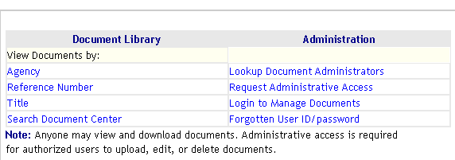
LOGIN
FORGOT USER ID/PASSWORD

Prior to accessing the Document Administration Center, Administrators must log in. Logging in is done via the Document Center Main Menu. Document Center validates the user ID and password and if they are valid the Main Menu is displayed.

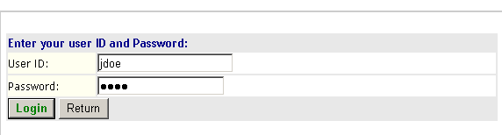
NOTE: If you forgot your User ID or Password, please click on “Forgot User ID/Password from the Main Menu, and it/they will be emailed to you

Forgotten User ID or Password
When a document administrator is granted access to the Document Center, they are issued a user ID and password that is used when they login to perform administrative tasks. If an administrator forgets their assigned user ID and/or password, the ID/Password facility will email them to the email address on file for them in the Document Center.
Clicking the Forgotten User ID/Password menu choice will open the Forgotten User/ID Password form. On the form, an administrator enters their last name and presses the Locate button.

Forgotten User ID/Password
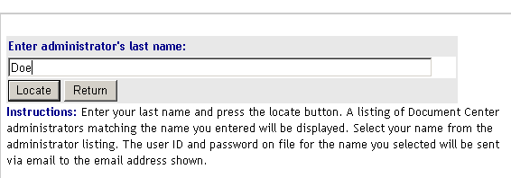

Document Center will search the administrator database and return a list of all administrators matching the name entered on the previous form. Clicking on the appropriate name link in the first column of the listing will result in email messages containing the user ID and password for the selected administrator to be mailed to the email address shown on the right.
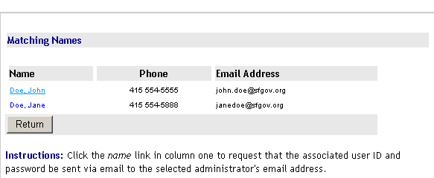
Document Center returns with all the Administrators with the last name of Doe. You would then click on your name from the list, and two separate emails will be sent to you. One with your login and one with your password.

Administration Center
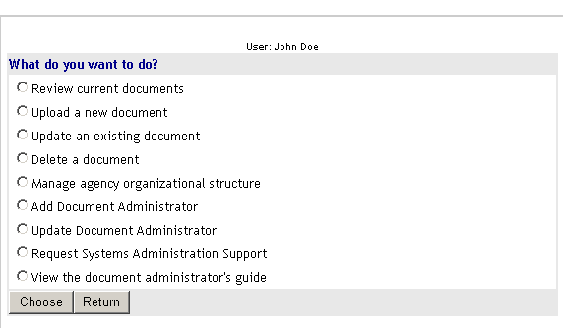
The Administration Center provides access to the various administrative facilities provided by the Intranet Document Center. All the facilities within this section of the Administration Center menu require that a user have been issued an ID and password.

In the next sections of this user’s guide, each Administration Center main menu choices will be explained in detail.
Review Current Documents

For administrators managing multiple agencys

The Document Center permits administrators to review documents for multiple agencies. Administrators who are authorized to access the documents of more one agency will be presented with an Agency Selection form to select the agency whose documents they wish to review. Administrators may only review the agencies that they have been granted access to; in this example: Academy of Sciences, HRIS Project and Intranet Document Center.

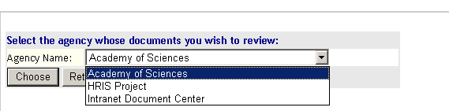

Select your Agency from the agency name dropdown list and press the CHOOSE button to continue the review current document. The CANCEL button will cancel the view and return to the main menu.

For administrators managing one agency (or department)

MOST Administrators will fall under this category, managing one department. After a successful login, you will see the Review Document Main Menu. (It will take you directly to your specific department without you having to choose one. The CANCEL button will cancel the view and return to the main menu.

In the example on the following page, we have chosen the Intranet Document Center as the ‘agency’ we would like to use.
review current documents (continued)
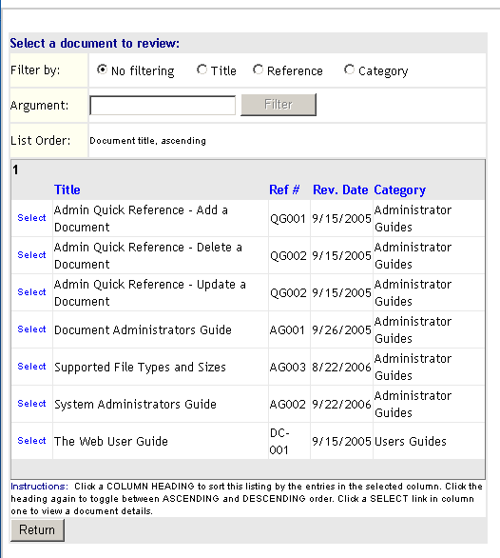

FILTER THE LISTING BY ANY OF THESE CATEGORIES LISTED

CLICK ON ANY OF THE HEADINGS TO SORT THE LISTING BY ASCENDING OR DESCENDING ORDER BY THAT COLUMN

CLICK ON THE SELECT LINK NEXT TO ANY DOCUMENT TO VIEW THE COCUMENT DETAILS

For administrators managing multiple agencys

Administrators who are authorized to access the documents of more one agency will be presented with an Agency Selection form to select the agency whose documents they wish to review.

The Document Center permits administrators to manage documents for multiple agencies. Administrators who are authorized to access the documents of more one agency will be presented with an Agency Selection form to select the agency whose documents they wish to upload.

Upload New Document
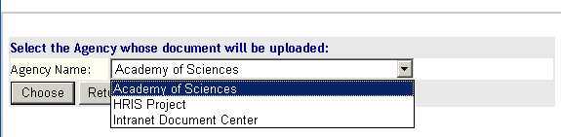

Select an agency from the agency name dropdown list and press the CHOOSE button to continue the document upload. The CANCEL button will cancel the upload and return to the main menu.

for administrators managing one agency (or department)

The Document Center permits administrators to upload new documents. If the administrator is managing one agency, they will be automatically moved to the New Document Upload form directly from the main menu.

Upload New Document – continued
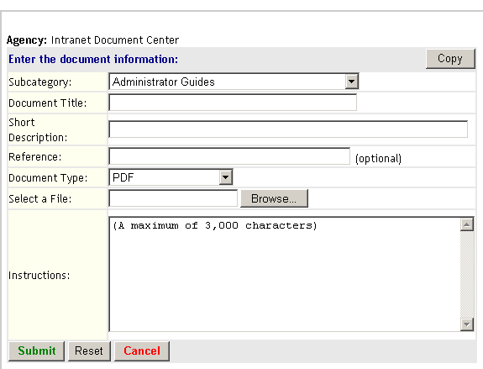
ALL Fields except reference
Are required Click on the SUBMIT Button – and you are done!
Fields

See the next page - FILTER THE LISTING BY ANY OF THESE LISTED

The file attachment
☞

Instructions for Completing the New Document Upload Form

Subcategory – Select the subcategory that matches the content of the new document. Some agencies do not have subcategories defined for their documents. If no subcategories have been defined for an agency, General Documents will appear as the default subcategory.

Document Title – Enter the document’s title. Document title is a required field.

Short Description – Enter a description of the document. This is a required field.
Reference – Enter a reference indication if one has been assigned. This is an optional field. “None” will be displayed on the web if a reference is not entered.

Reference - optional

Document Type – Select a document type from the dropdown list. Only the document types listed may be uploaded into the repository.

Select a File – Click on the BROWSE button to search the desktop’s file system for the document file to be uploaded. Selection of a file is mandatory. Go to the next page to see a screen shot of this!

Instructions – Enter an extended document description or instructions for use of the document. A maximum of 3,000 characters may be entered. HTML formatting may be applied. This field is optional and if no description/instructions are entered, “NONE” will be displayed on the web.

Click on the BROWSE button to search the desktop’s file system for the document file to be uploaded. Selection of a file is mandatory. You may retrieve the file from any location, just make sure it is one of the approved file types and the file type matches the file type you are uploading.

The PDF File that we would like to upload

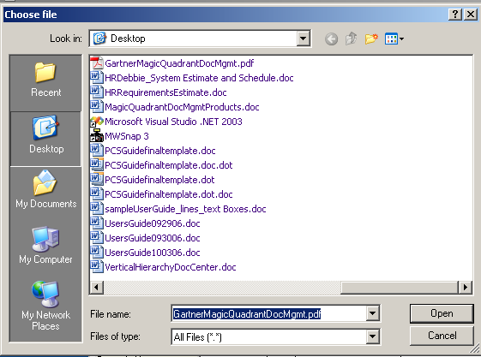

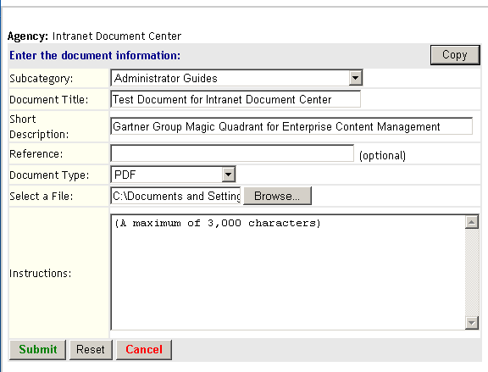
PDF File Type Chosen

Click on the SUBMIT Button – and you are done!

Upload New Document – Continued

Prior to processing a document upload, the Document Center will validate the contents of the various input fields. If an error is found, the Upload New Document form will be redisplayed with the field in error highlighted.
Example of Wrong file type error message

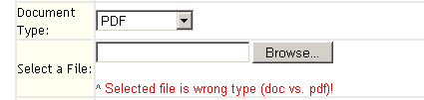

An example of a Document Center validation error is shown above. The error is the result of an administrator‘s attempt to upload a MS Word (doc) document file when the selected document type was PDF (Adobe).

The following are the validations performed prior to a document upload:

- A Document Title must be present.

- A Short Description must be present

- A Document file must be selected

- Document file size must not be larger than 2.0 Megabytes

- Document type selected and document file type must match

- Instruction/description text must not total more than 3,000 characters (including spaces)

After correction any errors, the administrator may resubmit the document upload by pressing the SUBMIT button. If there are no validation errors, Document Center will confirm that the document has been uploaded into the repository.

When done entering document information, pressing the SUBMIT button will process the document upload. Pressing the RESET button will restore default values to all input fields. Pressing the CANCEL button will cancel the upload and return to the main menu.

THE COPY FEATURE TO UPLOAD DOCUMENTS

When uploading new documents, the Document Center provides a COPY facility. The copy facility allows document information from an existing document to be copied into a new document. In other words, you can use the information that is required in the “Document Information Page” to fill in the fields for a new uploaded document. At first thought you may think you will seldom use this feature, but if you suddenly have over 10 documents that are very similar in format, like contracts, letters, forms, etc. to upload – this feature can save a lot of time!

In this example a document administrator has started by (1) Logging into the system, (2) Selecting Upload a new document, choose the agency for the document is to be uploaded to (if this Administrator maintains more than one) and the following screen appears:

Upload New Document – How it works
This is the screen that will come up when you request to upload a new document. It is a blank (not filled in) document information page from which you could type in all the required information (just like we did last time!) You could then attach a file and you’re set. BUT….The problem is that you have 35 contracts all with the same basic Document Information Page, just with different files attached. This is where the COPY feature is TERRIFIC! You make one basic Document Information Page, or copy one, and use it over and over, modifying the file names and locations and any other details necessary. This is where the COPY feature is TERRIFIC!
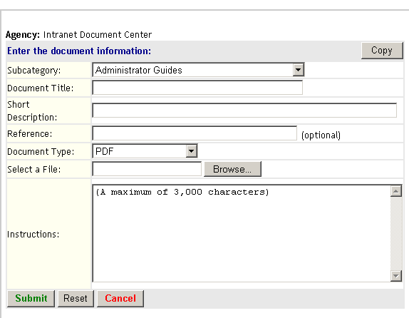
It is often easier to copy information from an existing document rather than typing everything in from the beginning

Pressing the COPY button on the blank document opens the listing of all available documents to copy from.

Upload New Document – Select the file to be copied
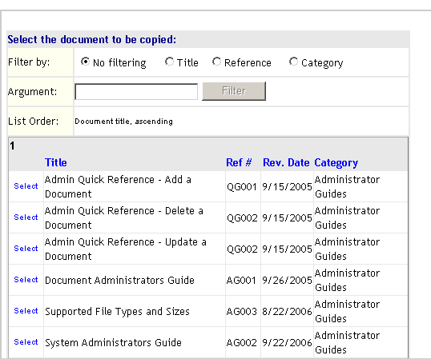

Upload New Document – Make any necessary changes

Once a document has been selected, the selected document’s information is copied into the new document. At this time you can change any of the information that was copied into the form. Using Select a File, you may need to add or change additional information about the document, but once that is finished, you are done!

Upload New Document – Submit

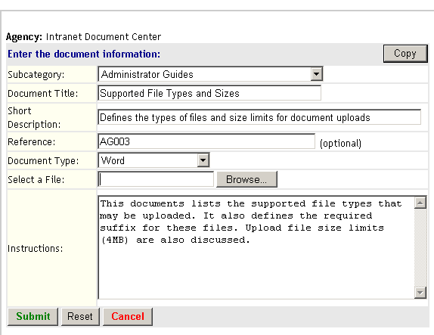
Edit an Existing Document

Step 1 – Select an agency (multiple agency administrators only)

Step 2 – Select a document to Edit

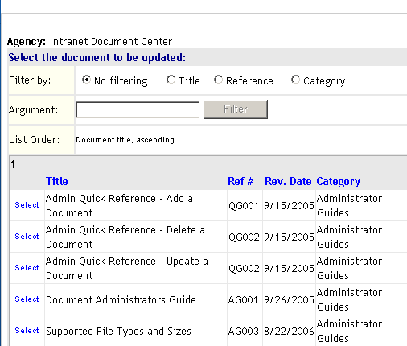

Step 3 – Make changes as desired

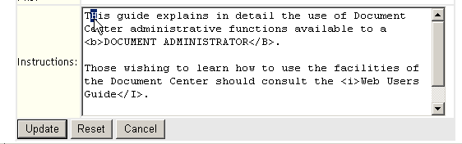

If a document file is selected using Select a New File, the new document file will replace the file currently stored in the repository.

When all desired changes have been made, pressing the SUBMIT button will process the update. As with new document uploads, input validation will be performed and any input errors must be corrected prior to completion of update processing.

Delete a Document

Step 1 – Select an agency (multiple agency administrators only)

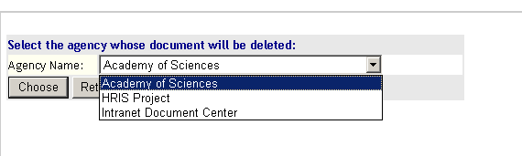

Step 2 – Select a document to delete

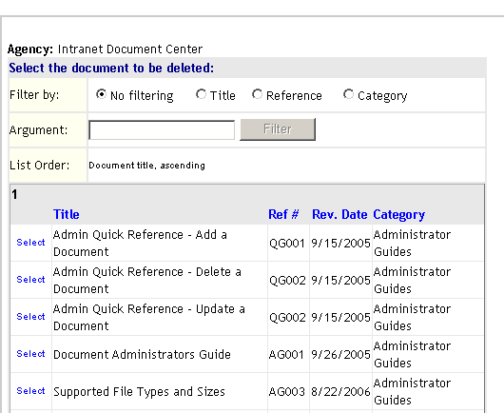

Step 3 – Confirm the deletion

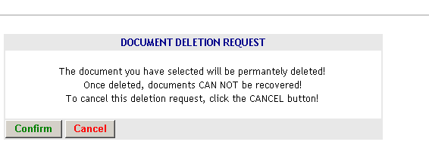

Press the CONFIRM button to delete the document. Press the CANCEL button to cancel the deletion operation and return to the main menu.

WARNING! Use the delete facility CAREFULLY! Once a document and its’ associated document file have been deleted they CAN NOT BE RESTORED!
Manage Agency Organizational Structure

For administrators managing multiple agency

For administrators managing one agency (or department)

Administrators are responsible for maintenance of the organizational structure of each agency whose documents they manage. This is done through a system of document categorization. Placing an agency’s documents into categories is helpful to web users. Categorization is particularly beneficial when an agency has stored many different types of documents in the repository Think of it as a big outline. You can make it very simple with only a few sub categories, or it can be a large 20 layer hierarchy of project tasks. The great thing is that you ca make it any way that you want, and change it whenever you want.
First we’ll look at the current listing before we make any changes:
From the Main Menu – Select View Documents by Agency

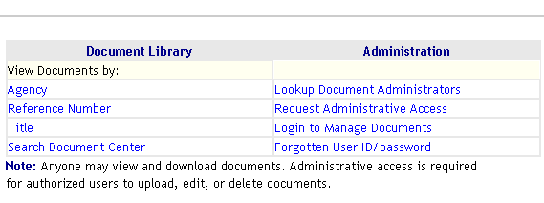

Current View
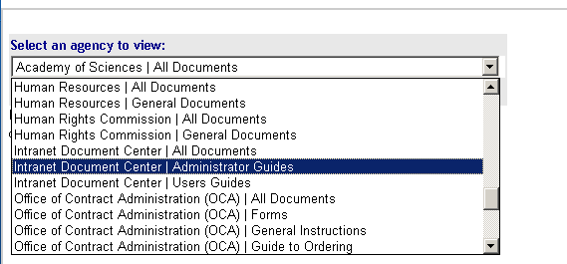
In the Documents by Agency listing example shown below, the Intranet Document Center has three document categories Every Department starts with an All Documents category. The categories that have been created are Administrator Guides and Users Guides. Creating a category for groups of similar subjects facilitates finding the desired document much faster and easier. Many departments use a project code name to manage the documents of a project instead of the department’s name.

In this example, the Intranet Document Center Administrator Guides category of documents was selected and the agency listing returns documents within the selected category. Categorization of documents within an agency is optional. You can now categorize documents within and agency, and have as many layers of categorization as you like! The listing of documents for the Administrator User Guides is shown below:

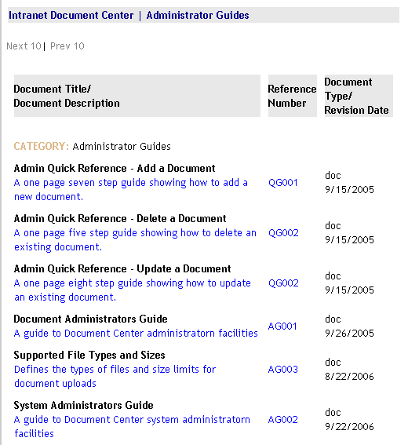

Manage Agency Organizational Structure
CLICK ON
LOGIN TO MANAGE DOCUMENTS FROM THE MAIN MENU

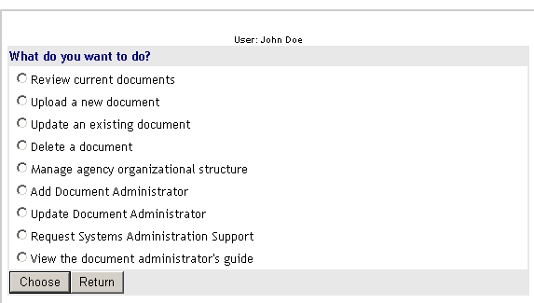
SELECT
MANAGE AGENCY ORGANIZATIONAL STRUCTURE

SELECT
ADD A DOCUM,ENT CATEGORY

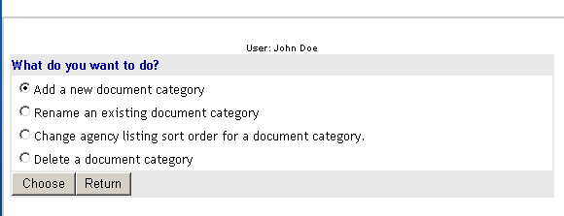

Manage Agency Organizational Structure menu
The four menu selections permit an administrator to ADD a new document category, RENAME an existing category (and re-categorize all associated documents), CHANGE agency listing and DELETE a document category and all associated document and document files. These functions will be explained in detail in the next sections of this guide.

Administrators who are authorized to access the documents of more one agency will be presented with an Agency Selection form to select the agency whose organization they wish to modify.

In this example, an administrator has been authorized to manage the documents a number of agencies. They have chosen the Add a New Document function on the Maintain Organization menu. Because this administrator manages several agencies, a selection page has been displayed so that the administrator can select the agency that will receive a new category.
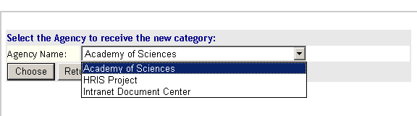

A similar page is displayed for the other two Maintain Organization menu choices. These pages will not appear if an administrator manages only a SINGLE AGENCY.

Organizational Structure – Adding a new Document Category

The Add a New Document Category facility permits administrators to create new categories of documents within the document center.

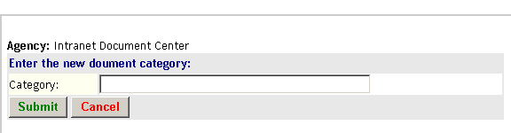
In this sample and administrator is preparing to add a category called Technology Presentations to the Intranet Document Center.
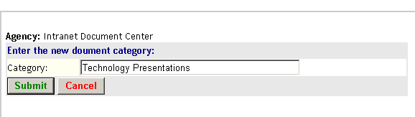
If the new category is accepted, Document Center will confirm addition the new category for the selected agency.
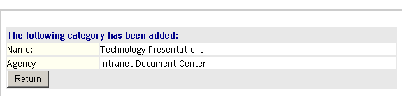
If an administrator requests addition of a category that has already been defined for an agency, Document Center will display an error message.

NOTE – Because of web browser caching, a newly added category MAY NOT APPEAR in the add document / edit document pages subcategory dropdown list until the administrator closes and re-opens their browser.

Organizational Structure – Renaming an existing Document Category

The Rename an Existing Document Category facility permits administrators to change the descriptive text displayed for an existing category of documents. Renaming does not change the population of documents that are associated within a category but only changes the TEXT that describes the documents within the category.

Selecting the category rename option from the main menu displays the rename category page. In the sample below, an administrator is requesting that the Demonstration Category be renamed to Changed Category.

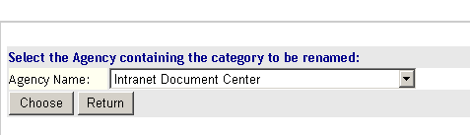

Rename Document Category
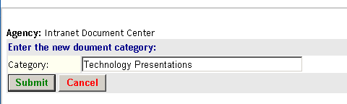

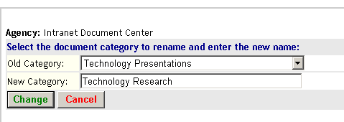

When the rename is completed, Document Center confirms the change.

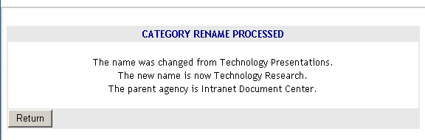
The new listing is shown below

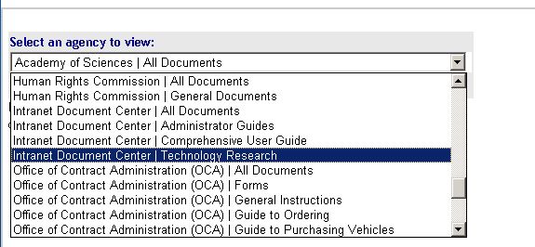

Note that the document population (the documents within each category) REMAINS THE SAME.

Organizational Structure – Change the sort order for a document category
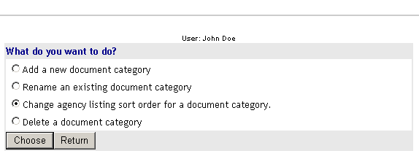
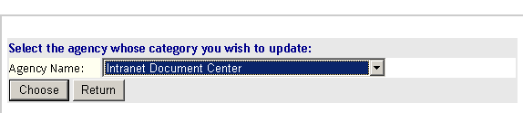

Current order without changes:
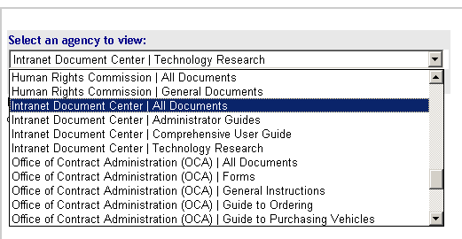

Chang sort parameters to display Administrator Guides in Descending order

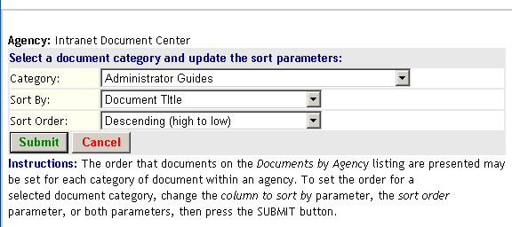

View new order with Changes:

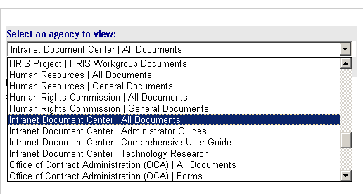

Organizational Structure – Sort Parameters for each category 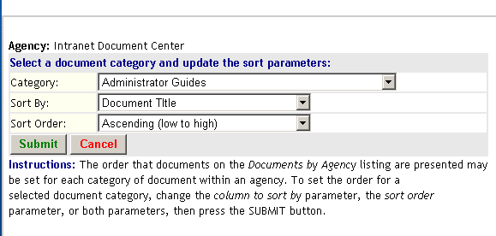

Delete a Document category

The Delete a Document Category facility permits administrators to remove an existing document category along with all documents and document files within the deleted category. IMPORTANT! Deleting a document category also deletes ALL ASSOCIATED DOCUMENT ENTRIES AND DOCUMENT FILES within the category. Once they are deleted documents and document files CANNOT BE RECOVERED!

Selecting the delete category option from the main menu displays the delete category page. In the sample below, an administrator is requesting that the Demonstration Category be deleted.

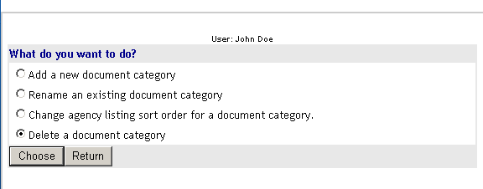

When the DELETE button is pressed on the delete document category page, Document Center presents a confirmation page.

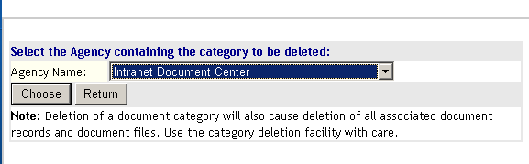

Pressing the CONFIRM button on this page will process the category deletion.

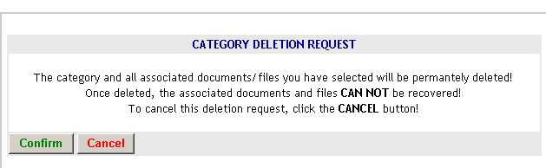Pressing the CANCEL button will cancel the deletion request with the category, associated documents, and document files remaining intact.

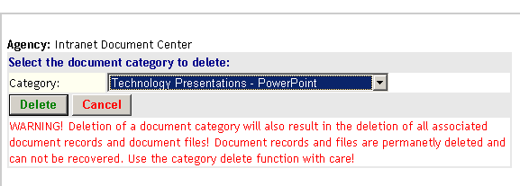

In this example, the Demonstration Category, all associated documents, and document files have been removed from the repository.

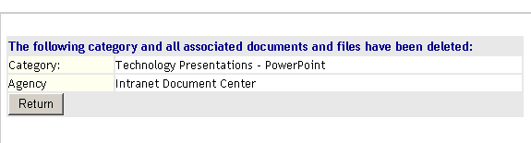

Add Document Administrator
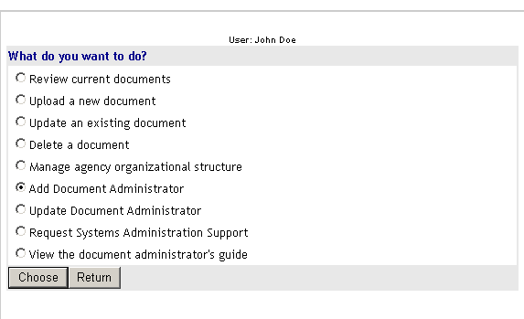

Add Document Administrator – Main Page
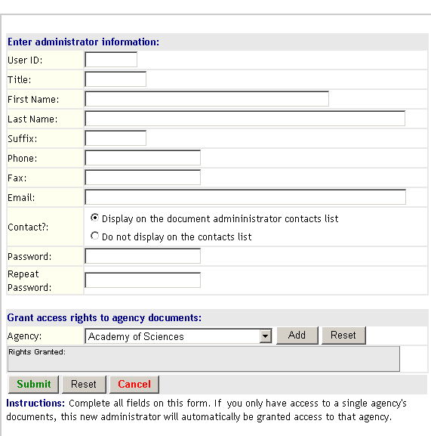

Update Administrator Information

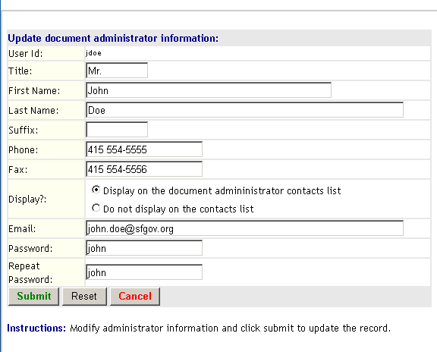

Request System Administration Support
Each of these actions automatically generates an email with all the necessary details to perform the requested action. The email is sent directly to the Document Center Webmaster to make the appropriate change(s).
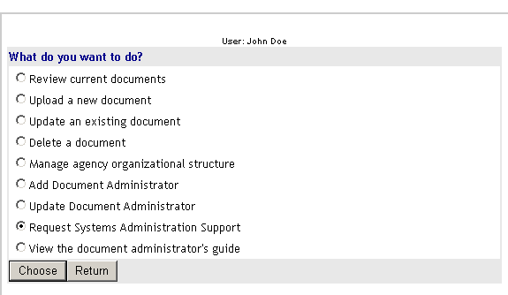

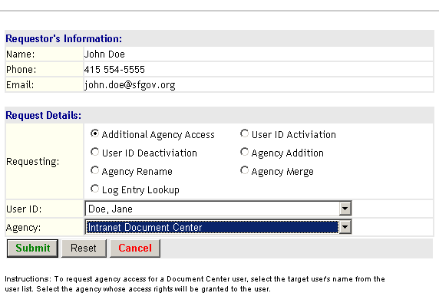

Additional Agency Access
To request agency access for a Document Center user, select the target user's name from the user list. Select the agency whose access rights will be granted to the user.

User ID Deactivation
To request deactivation (prevent login access) of a Document Center user, select the target user's name from the user list.

Agency Rename
To request change of an agency's name, Select the agency from the list and enter the new name of the agency in the NEW NAME box.

Log Entry Lookup
To look up of information from the Document Center's activity or security logs, select the log of interest and provide details about the event of interest

User ID Activation
To activate a Document Center user, select the target user's name from the user list

Agency Addition
To request addition of a new agency to the Document Center, Enter the new agency's name and their FAMIS code if applicable.

Agency Merge
To request merger of two existing agencies, select the agency to be merged from the FROM AGENCY list. Select the target agency from the TO AGENCY list.

